**Lab Exercise 5**

Topic: Android Persistence

**PART 1**

Implement the Preferences example from the lecture slides.

*Guidelines:*

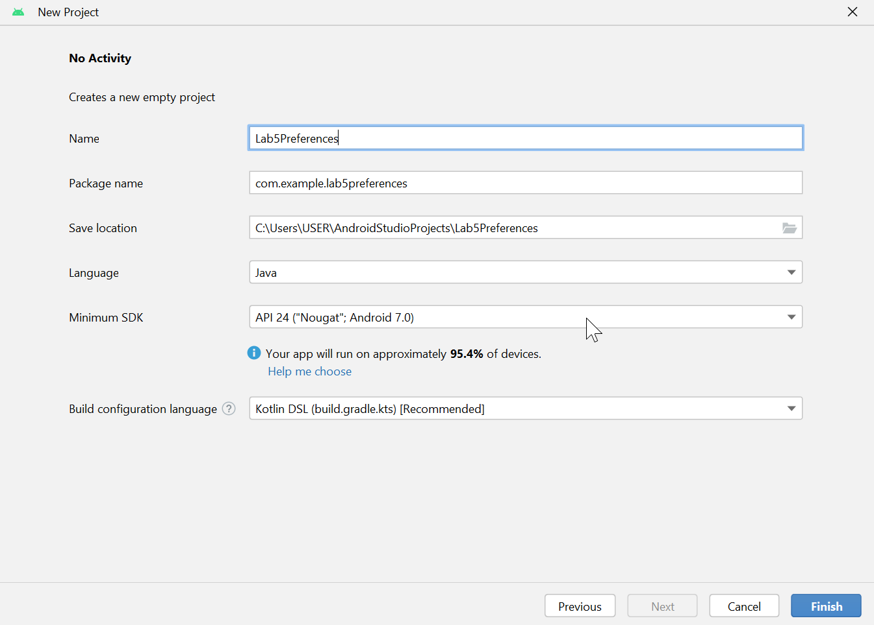

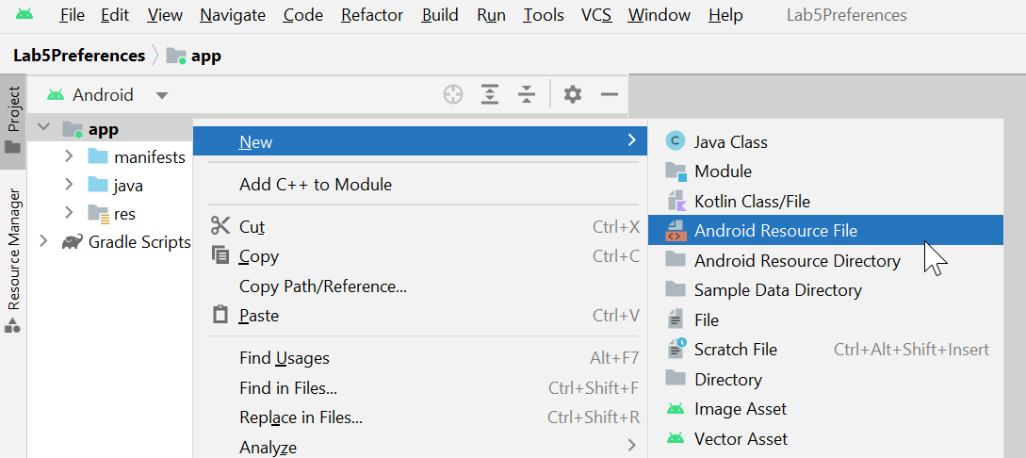

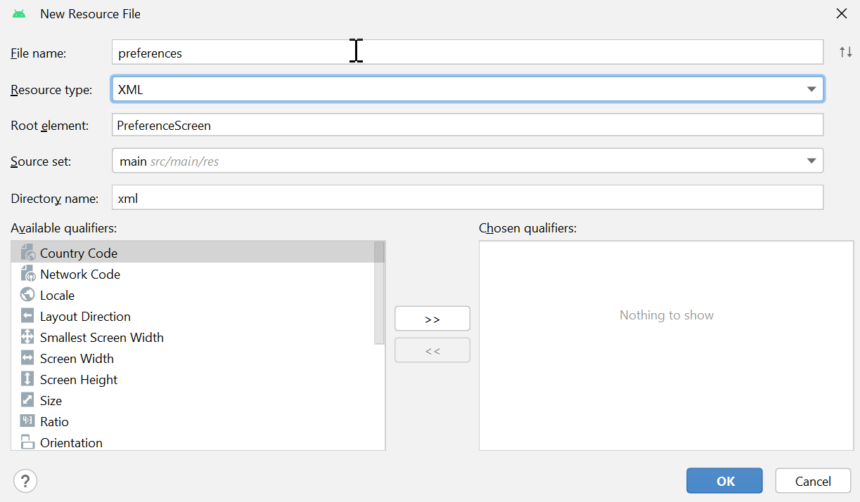

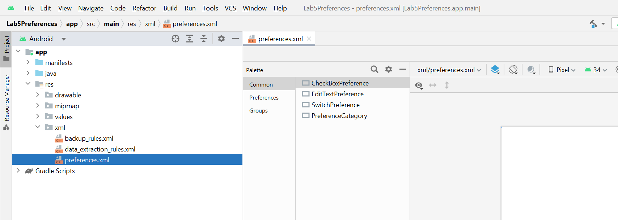

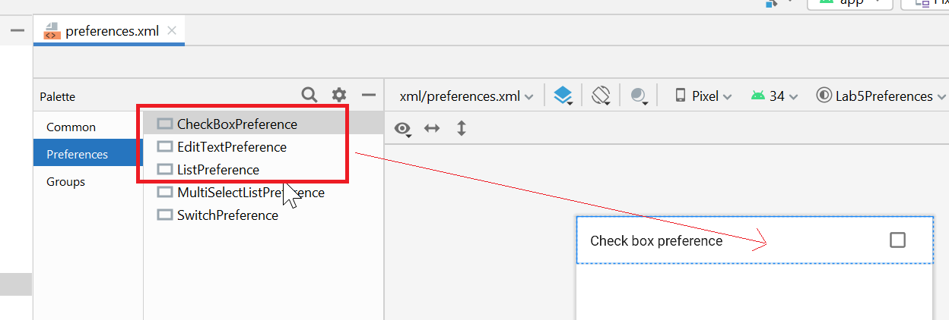

Define 2 string arrays: updateInterval and updateIntervalValues in the strings.xml resource file. UpdateInterval stores the text we display in the form where as updateIntervalValues are the values associated with the text (just like the concept of <select><option value=”1000”>Every 1 second</option></select> tags in HTML)

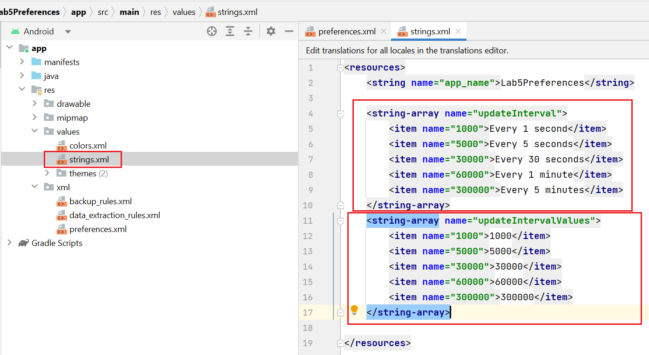

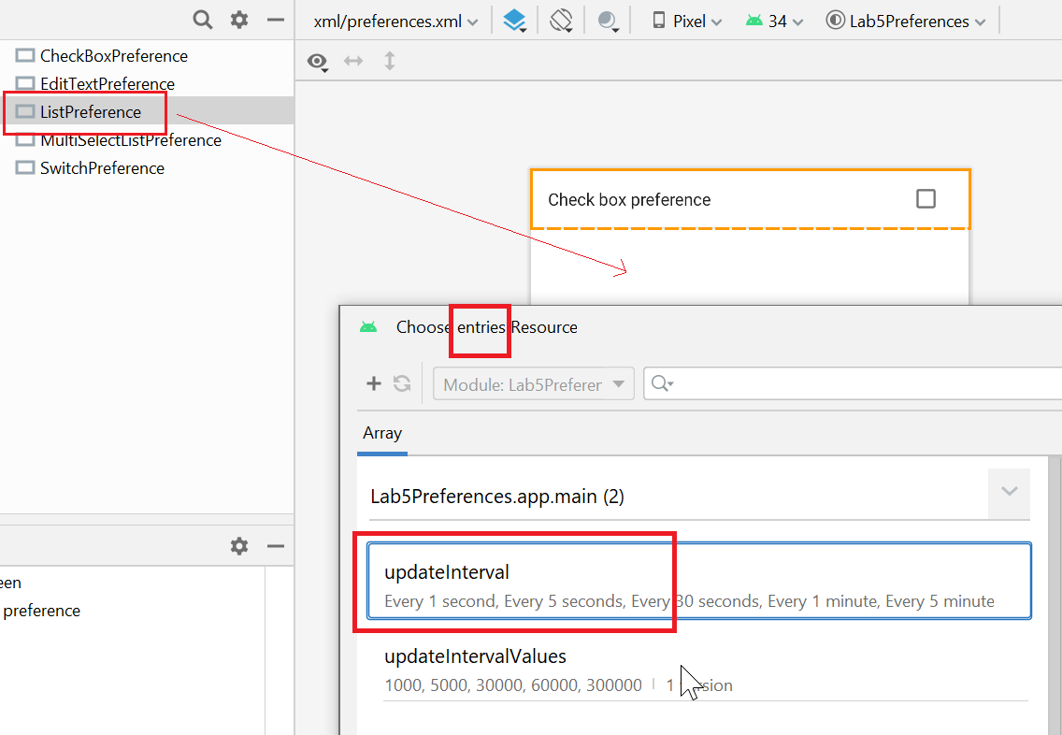

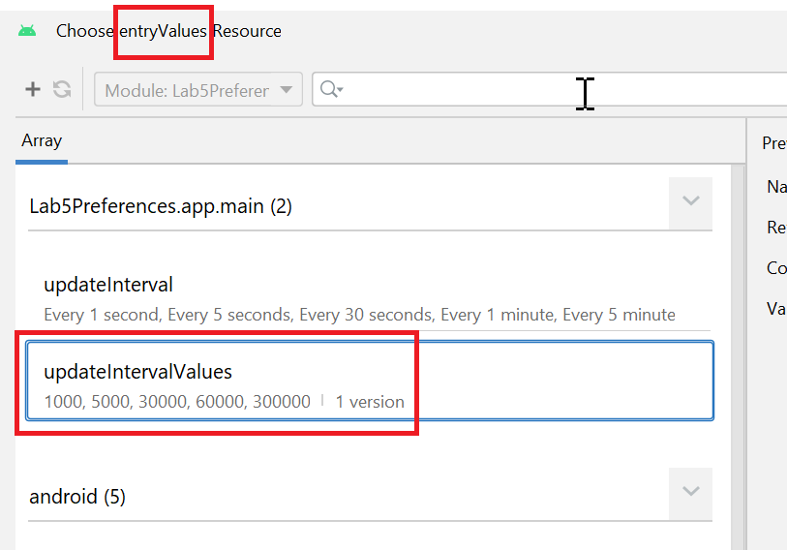

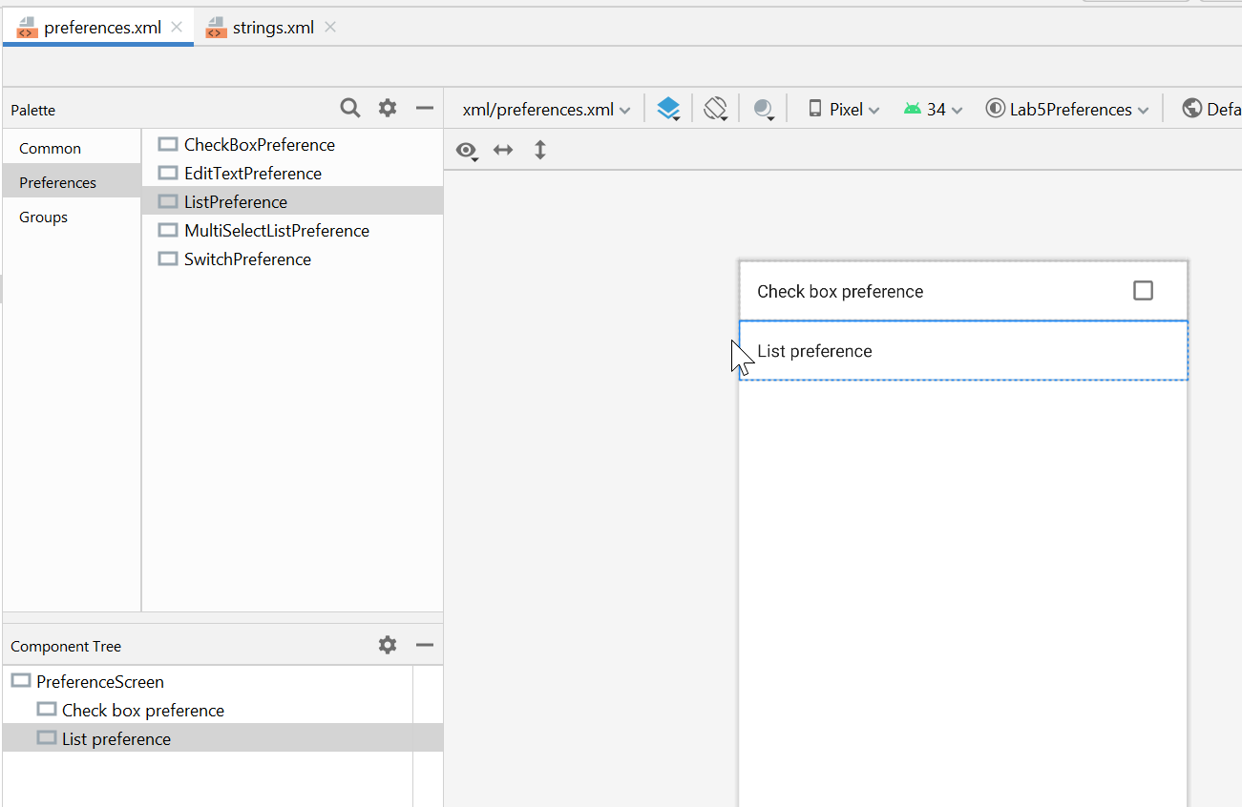

Instead of using wizard to create preferences.xml resource, you can do the same thing by writing some pieces of code.

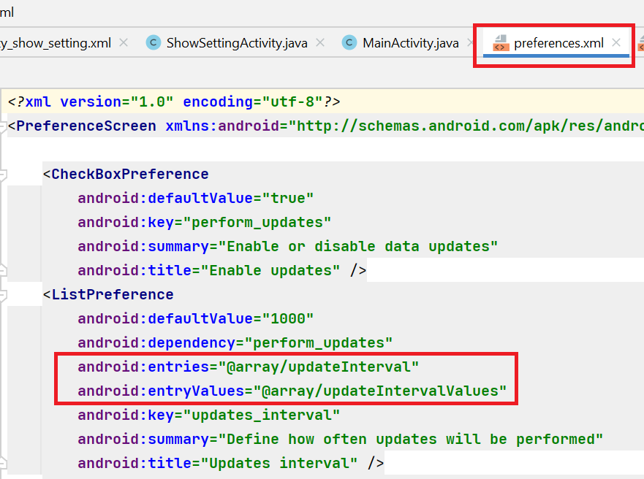

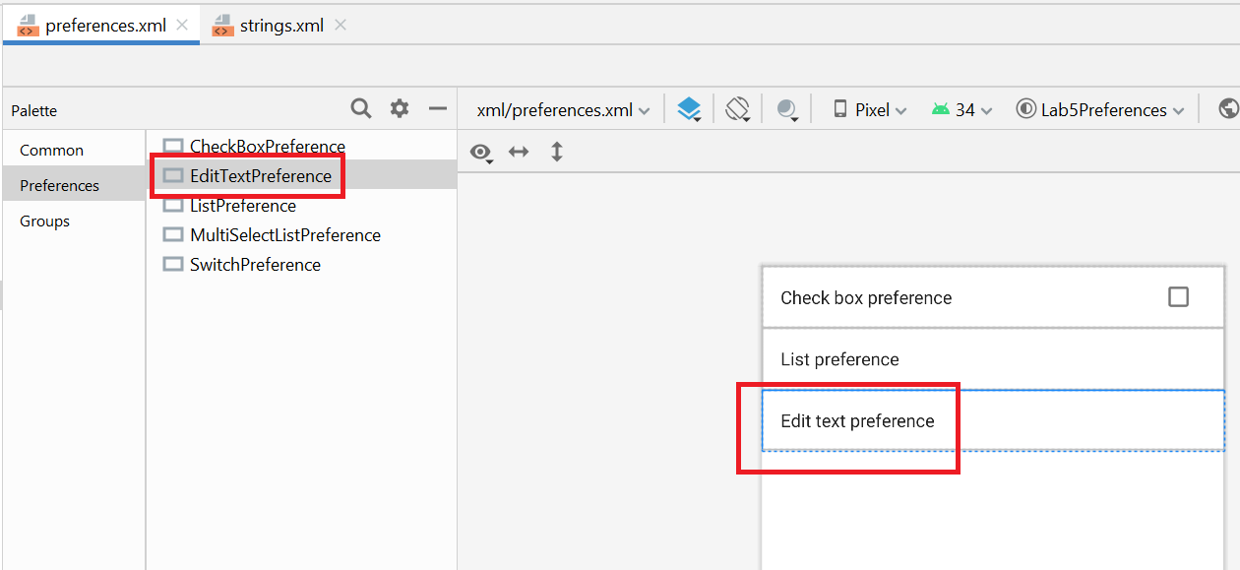

Update preferences.xml

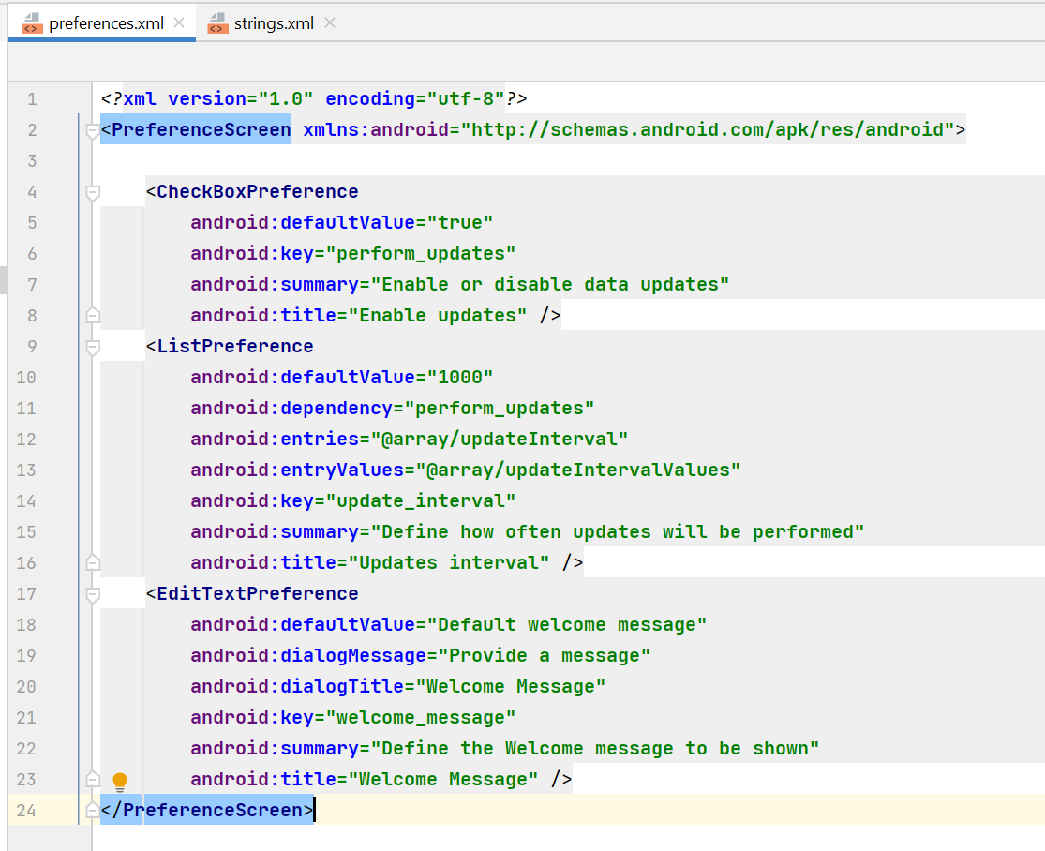

Now let’s plug in androidx.preference library. This library provides us with some API to handle CRUD for preferences.

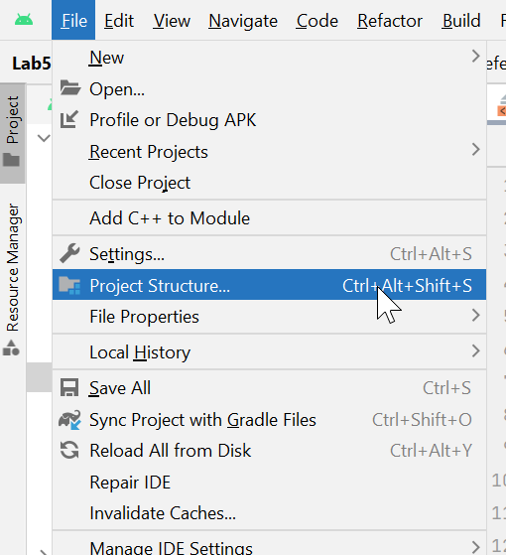

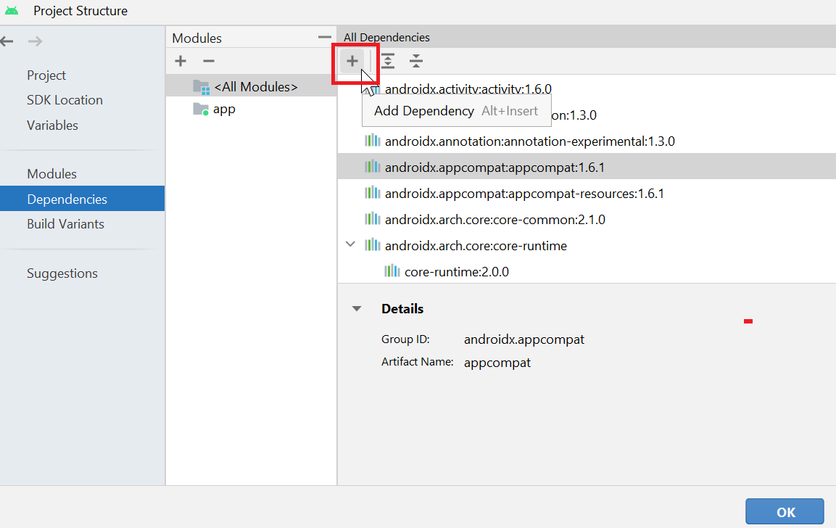

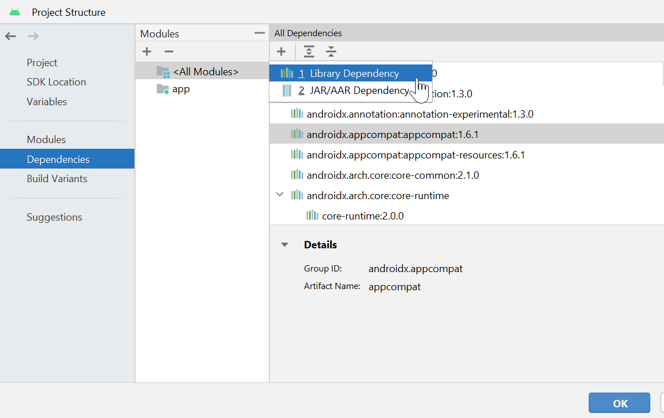

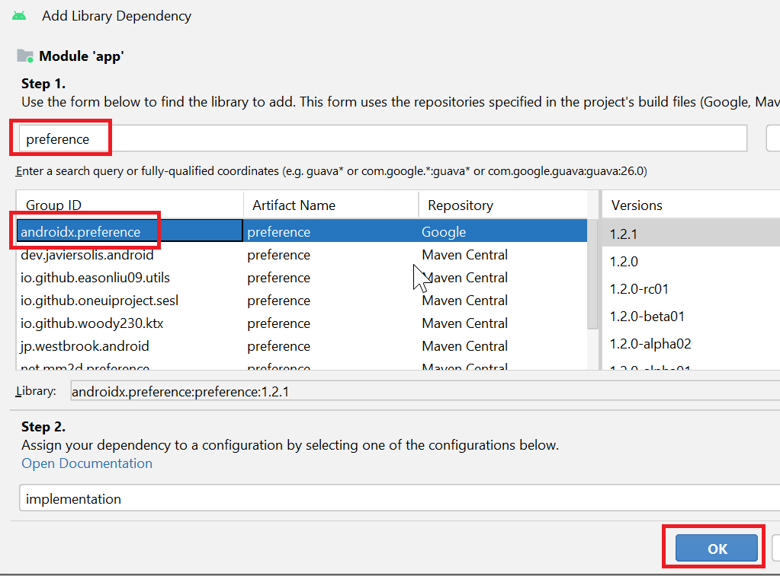

Create an empty main activity

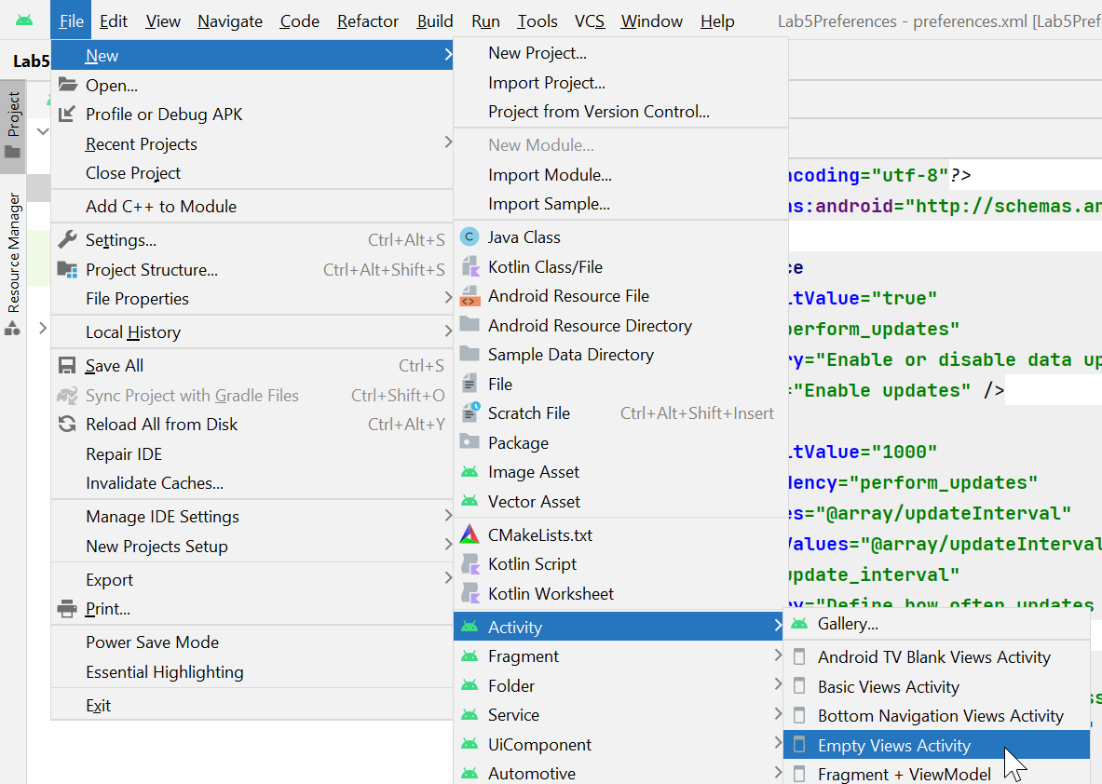

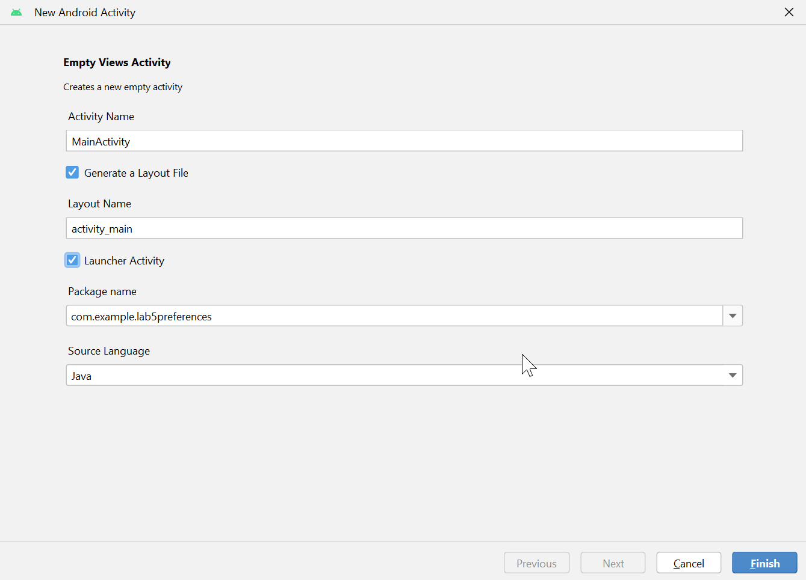

Create a menu resource file: res ->New-> Android resource file

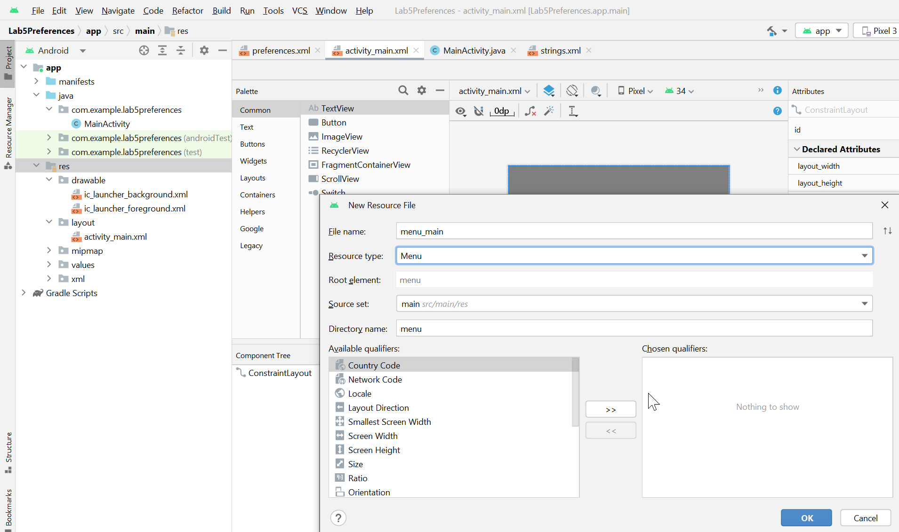

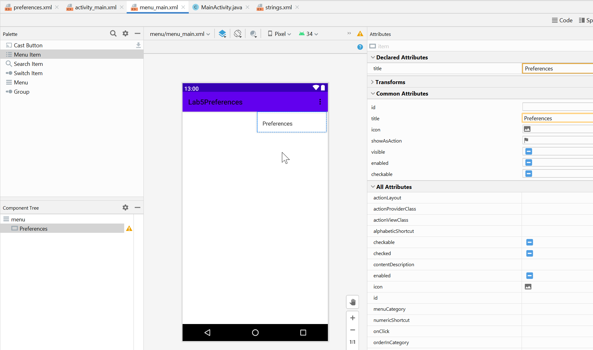

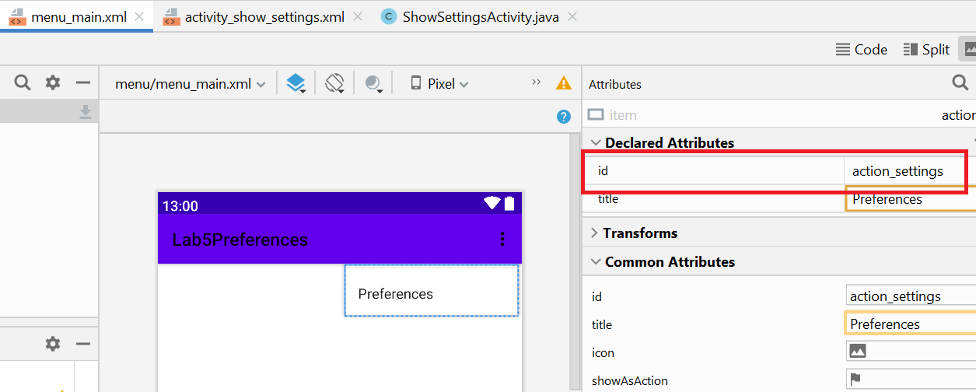

Attach the menu to the title bar

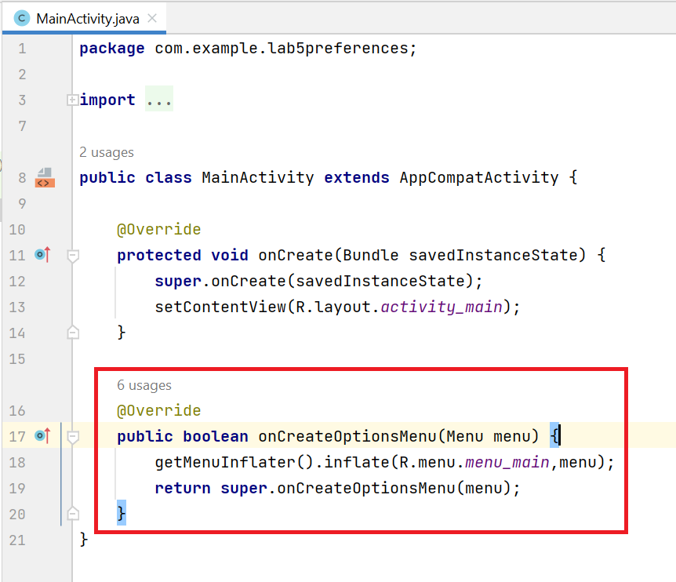

Run the app and see the menu shown

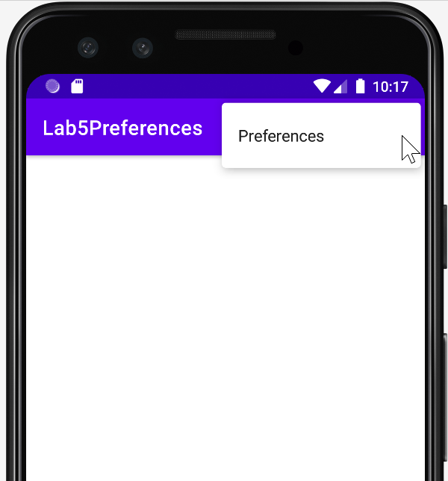

Now we show the preferences form using a built-in class PreferenceFragmentCompat. As this is a fragment, we can show it like showing a view (GUI component) in an activity at runtime (by adding a fragment dynamically to the activity).

Create a second activity which we use to display the settings

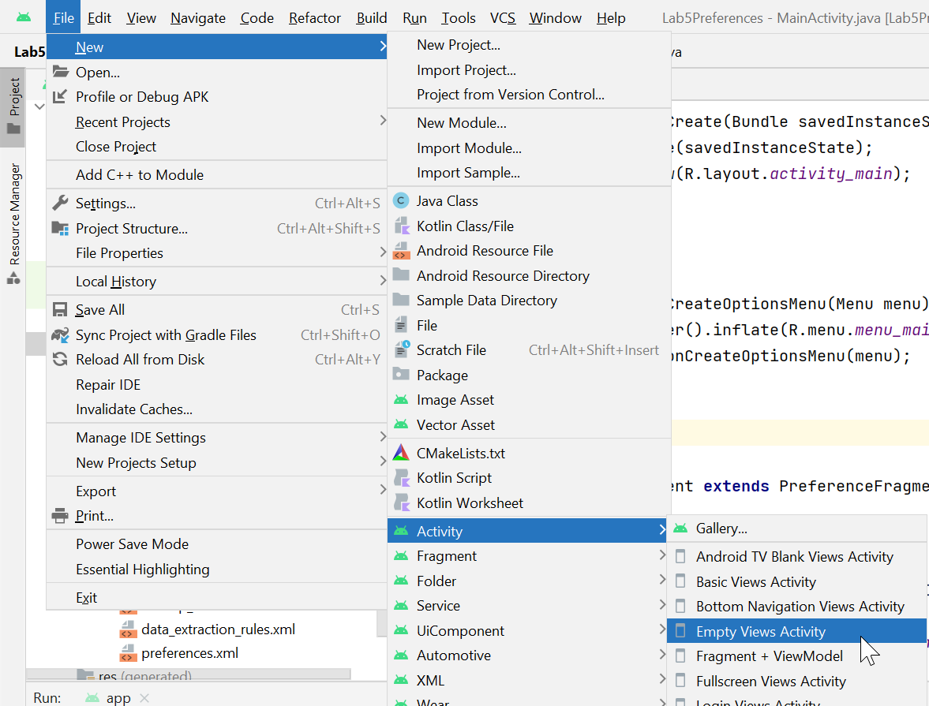

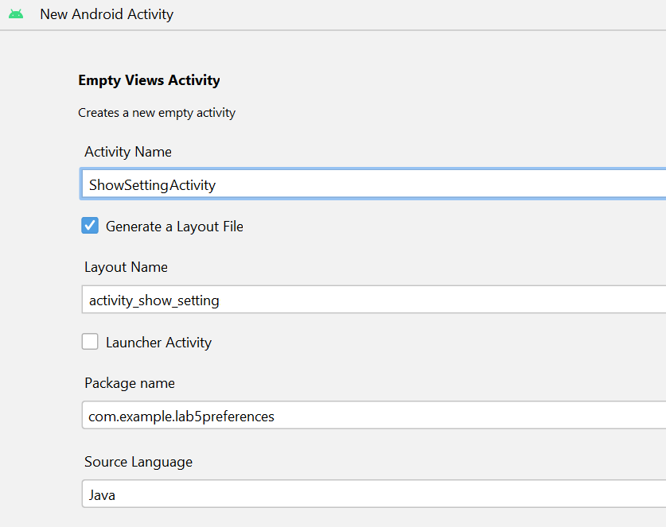

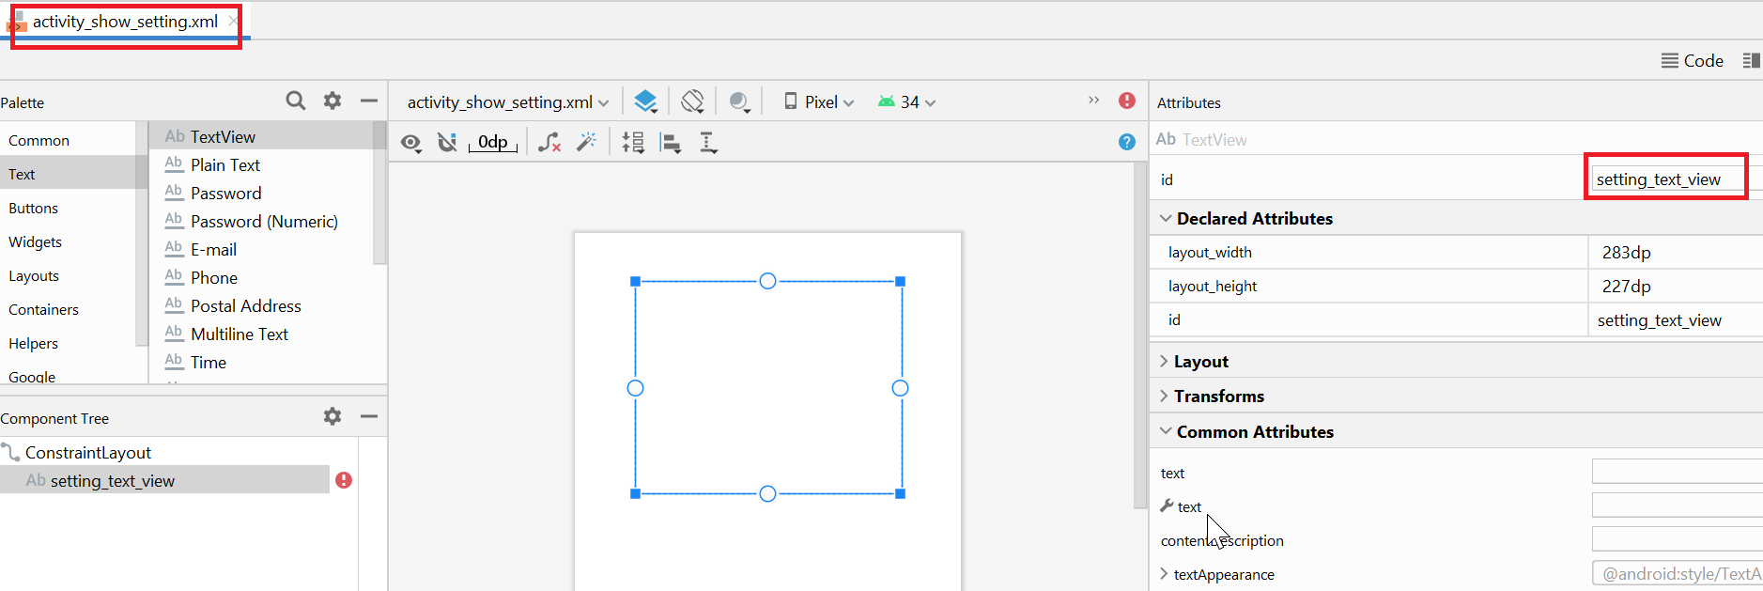

Now from main activity, we show the second activity (ShowSetttingActivity)

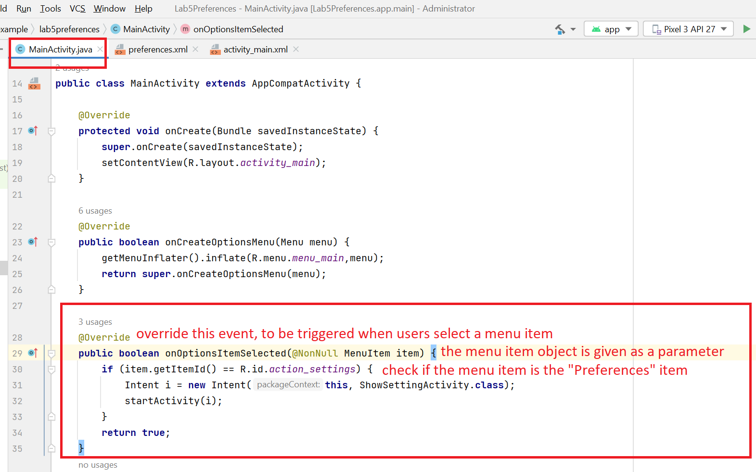

Read the preferences and show them in the 2nd activity (Notes: preference XML file may not exist on the device if you have not run the app)

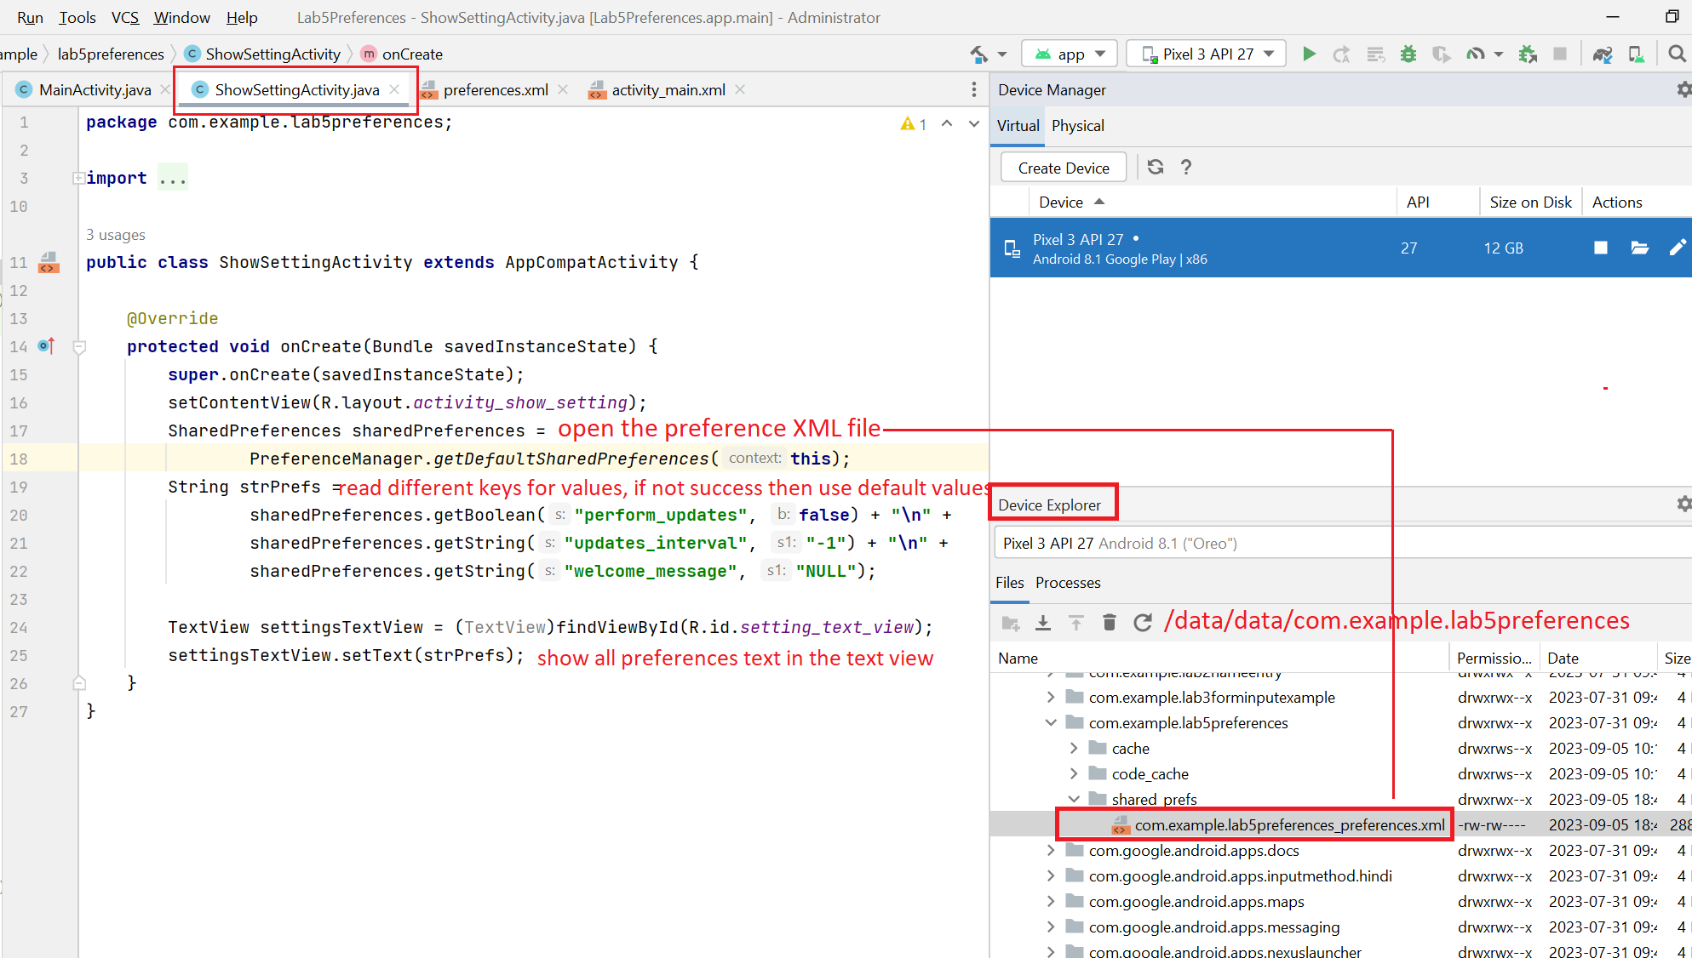

The final step is to make use of PreferenceFragmentCompat which is a built-in fragment class. Remember that we already design the layout for the preferences. Now we use PreferenceFragmentCompat to display this layout.

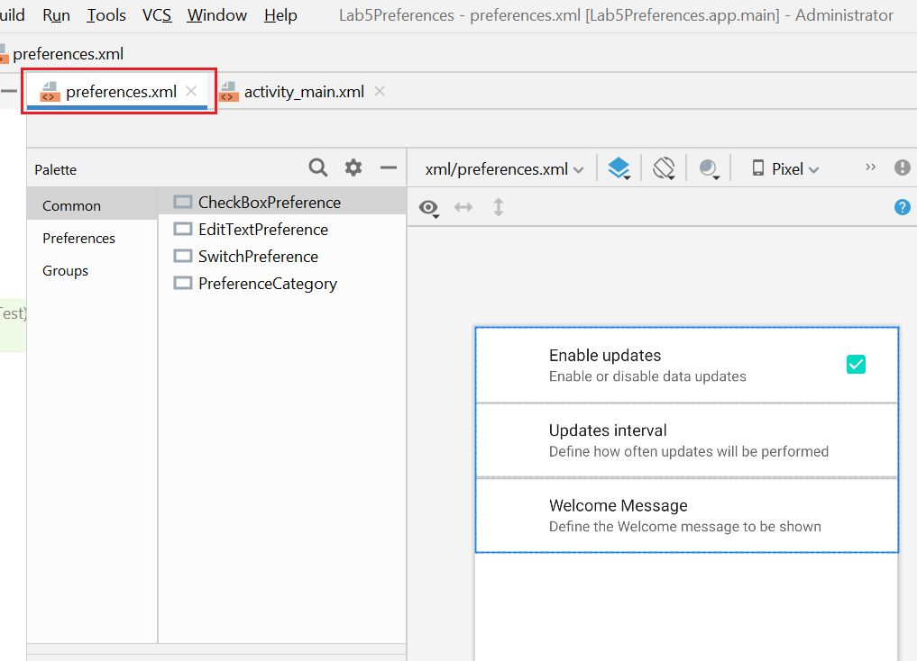

Remember that a fragment is a portion of a form. We will display the preference fragment within MainActivity. In order to display a fragment, the MainActivity must have a fragment container.

Now let’s create a fragment container in the MainActivity.

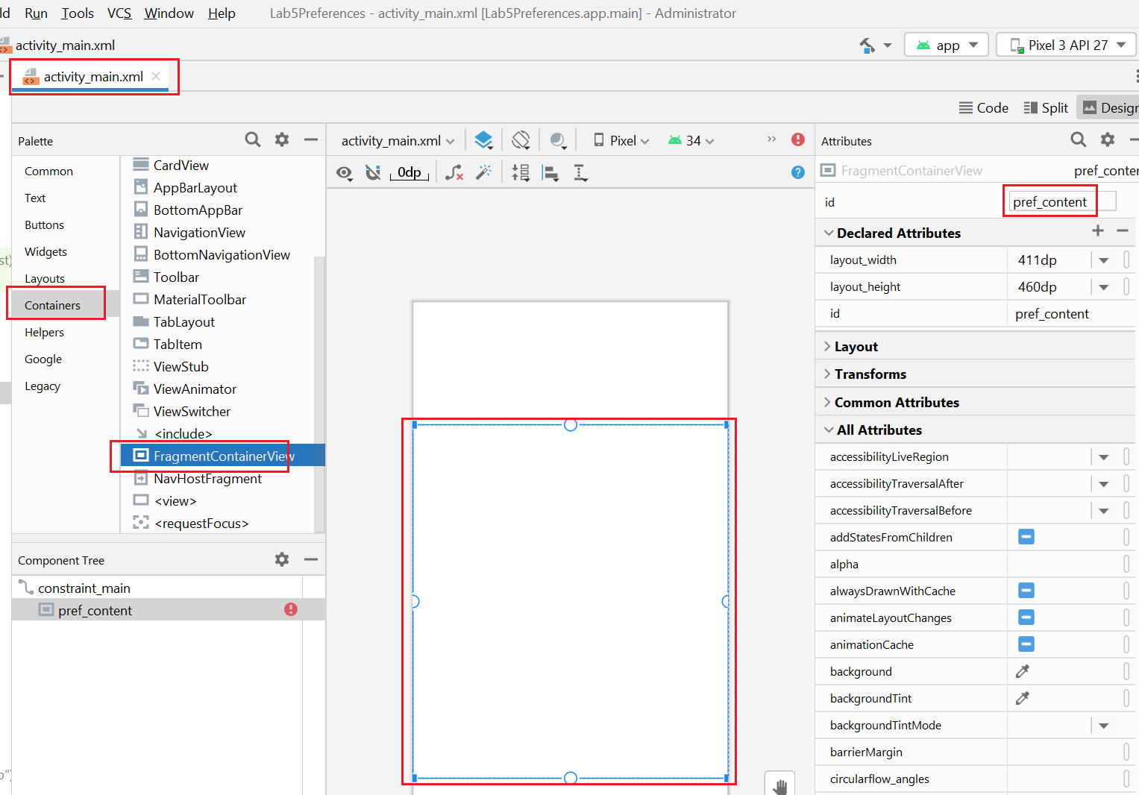

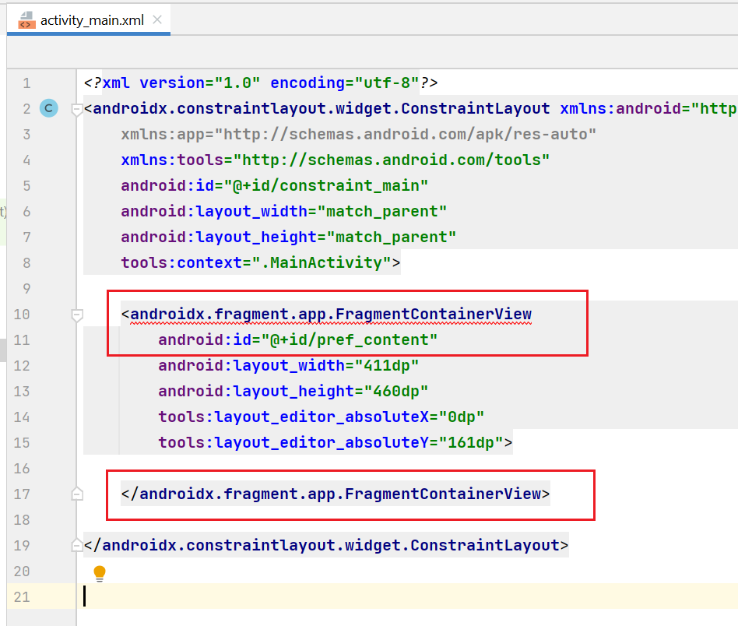

Make use of PreferenceFragmentCompat to display the fragment

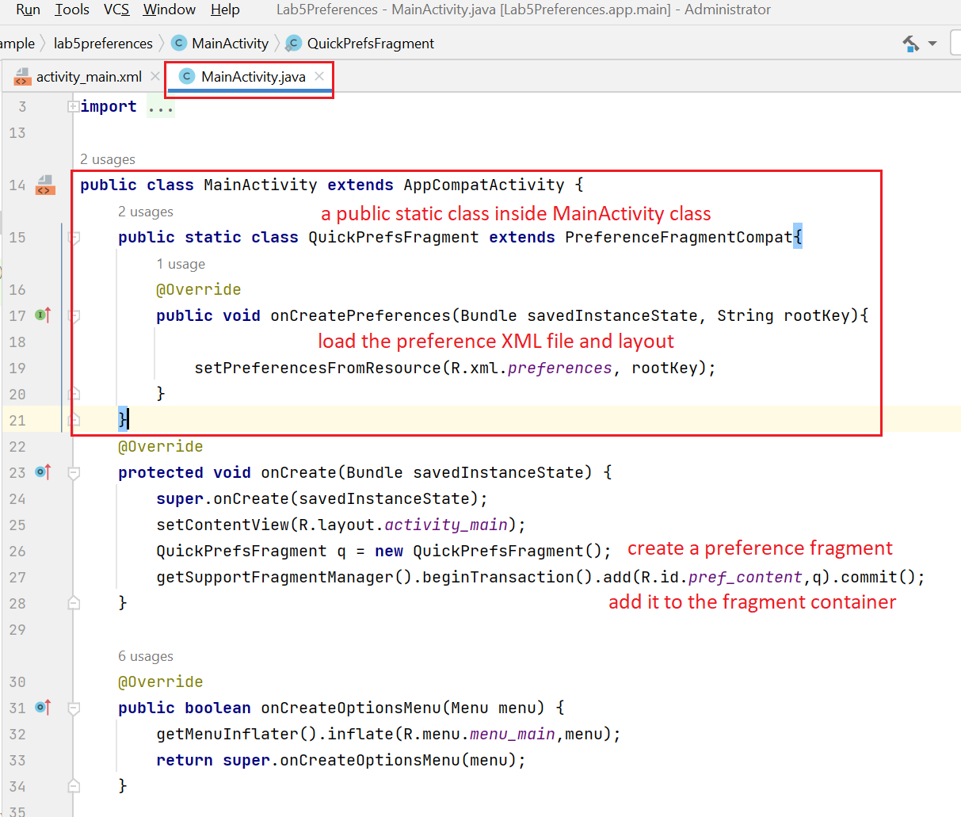

Run and check the app

**END OF PART 1**

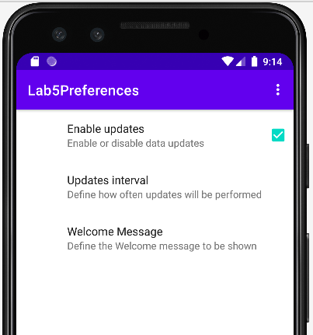

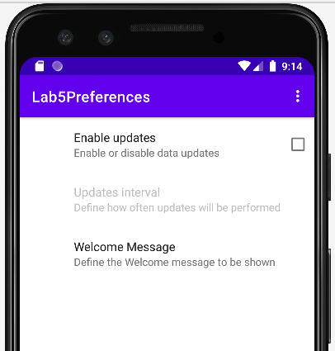

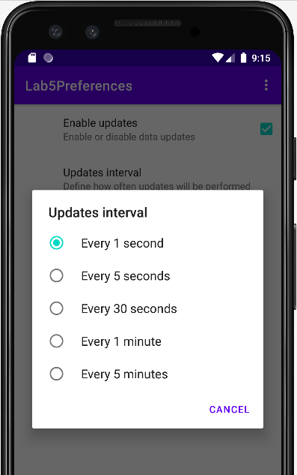

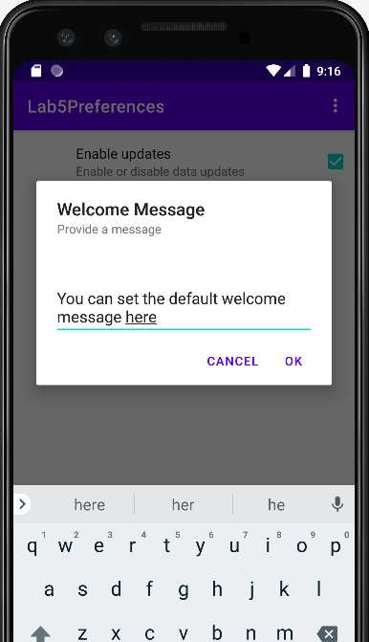

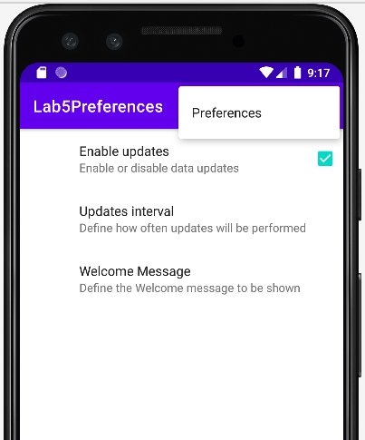

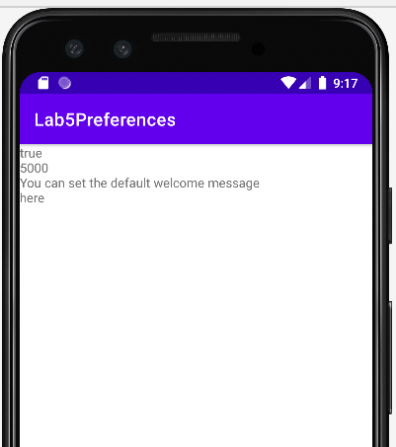

**END OF PART 1**

**PART 2**

Implement the File example from the lecture slides.

*Guidelines:*

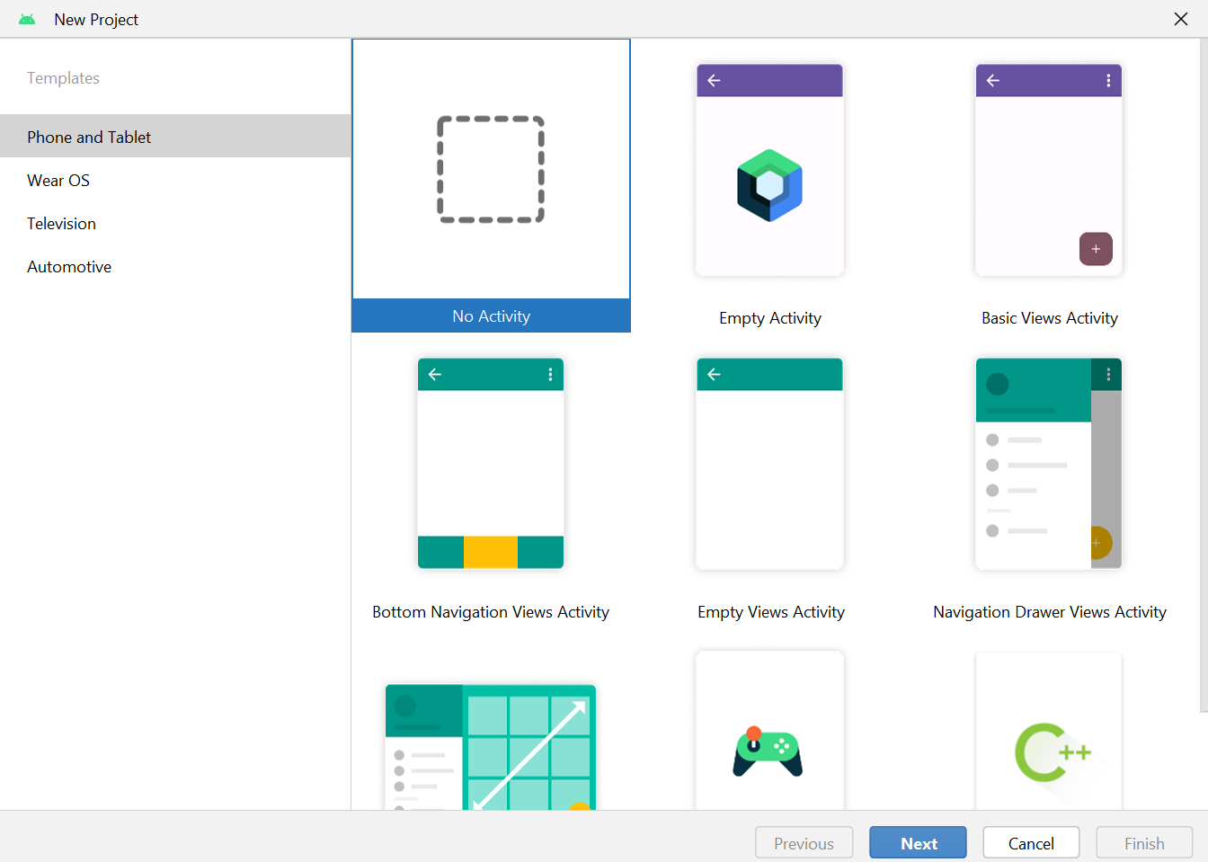

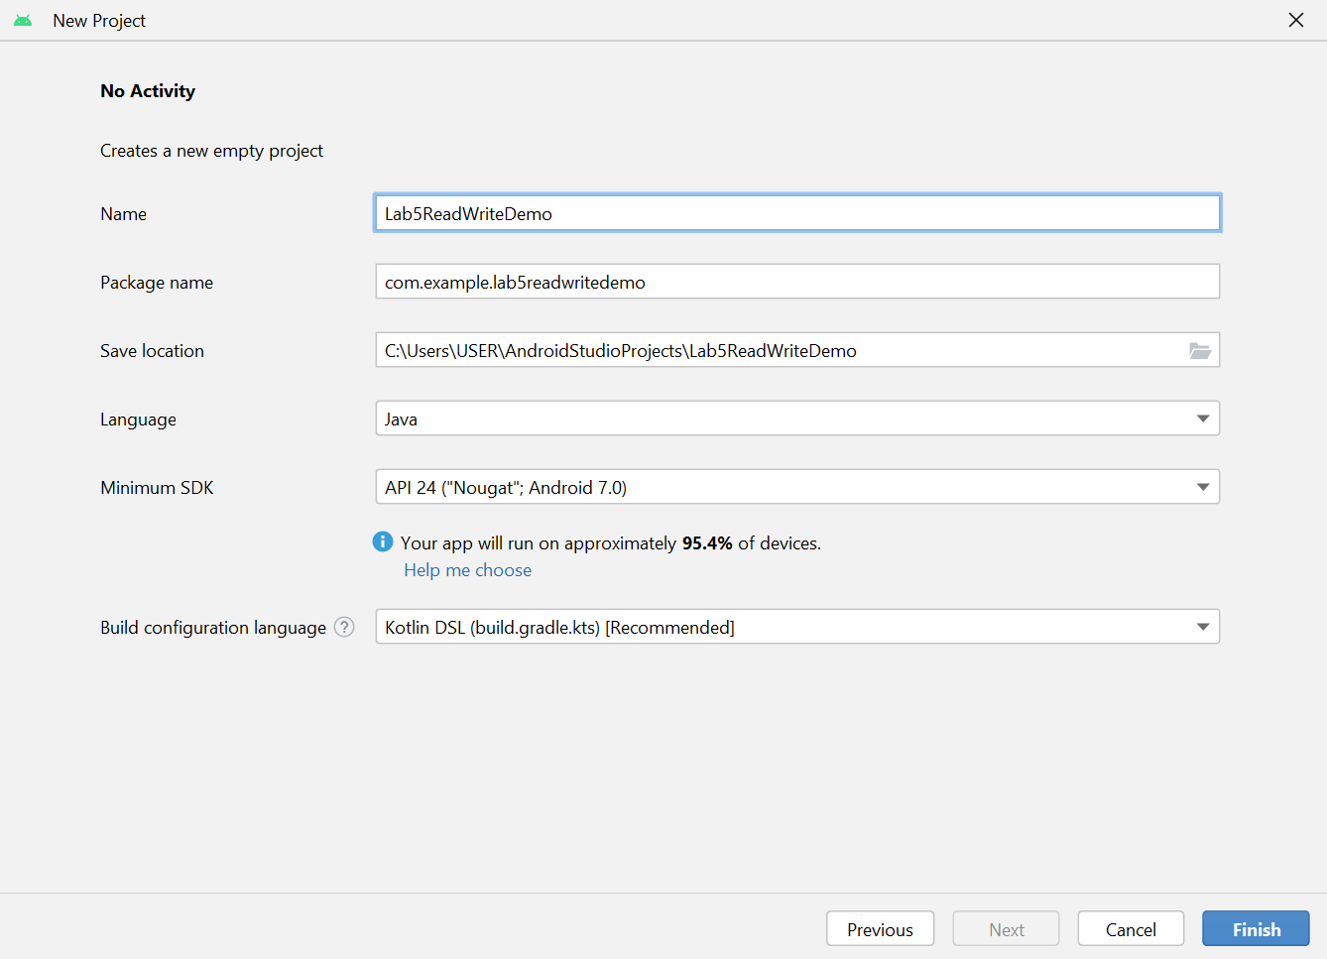

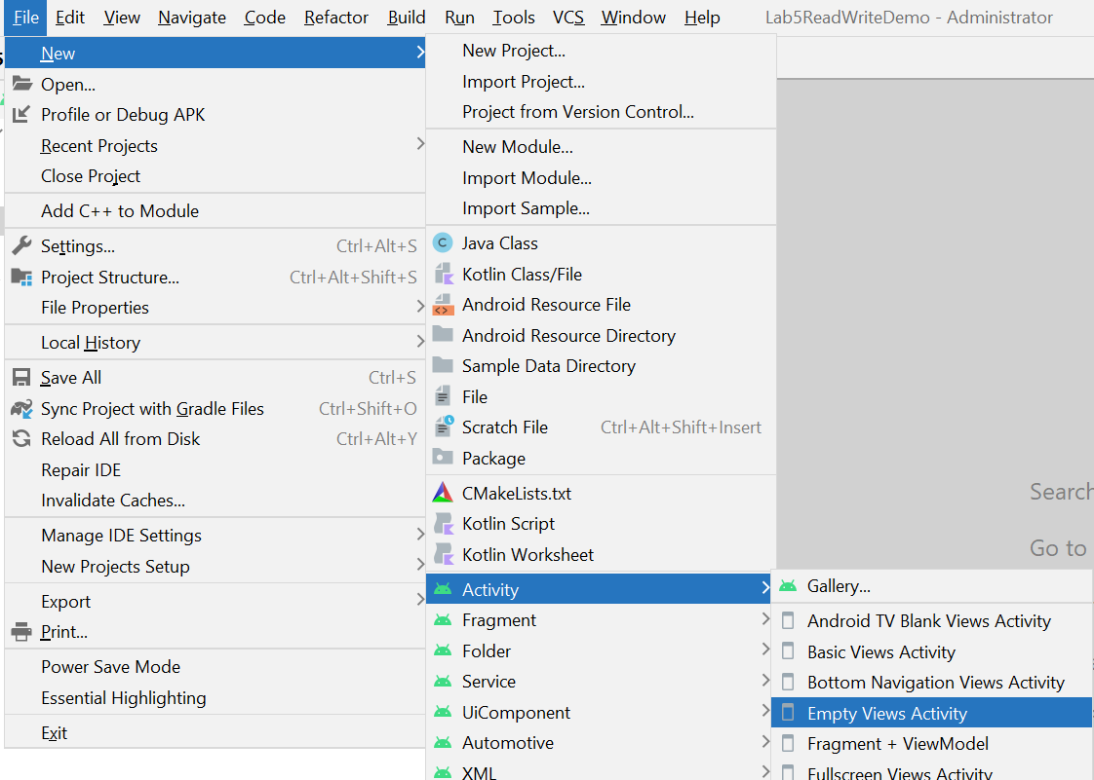

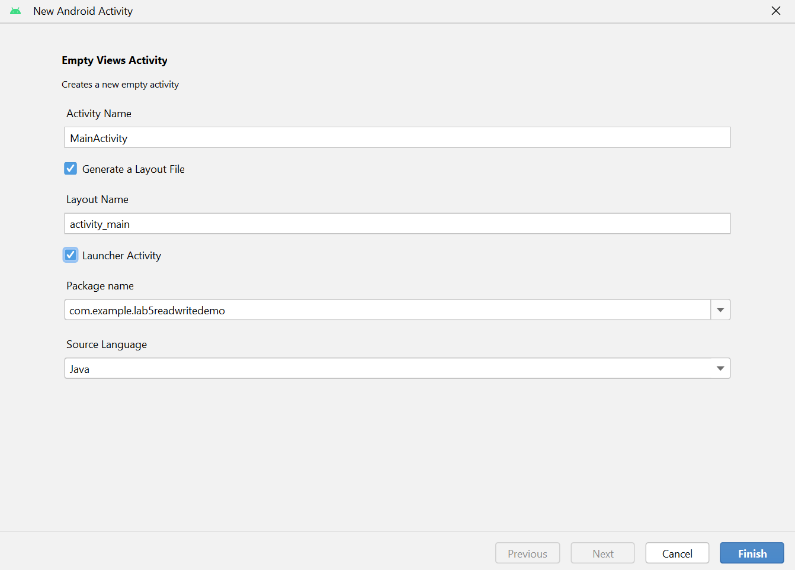

Override 2 events onPause() and onResume()

We will make this app to temporarily store the data on the GUI to a file when the users get away from the app. After that when the users get back to the app, all the GUI data is restored back from the file.

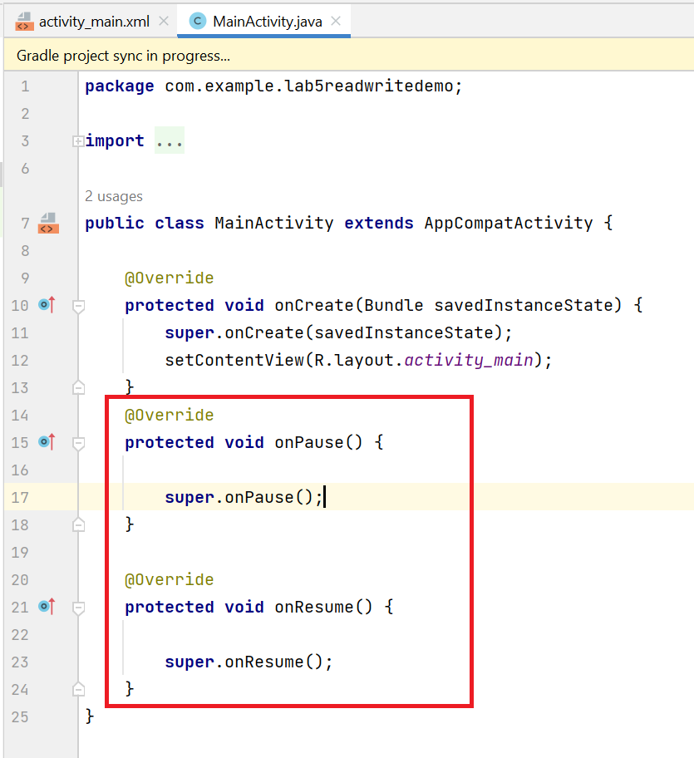

Create a multi-line edit text view

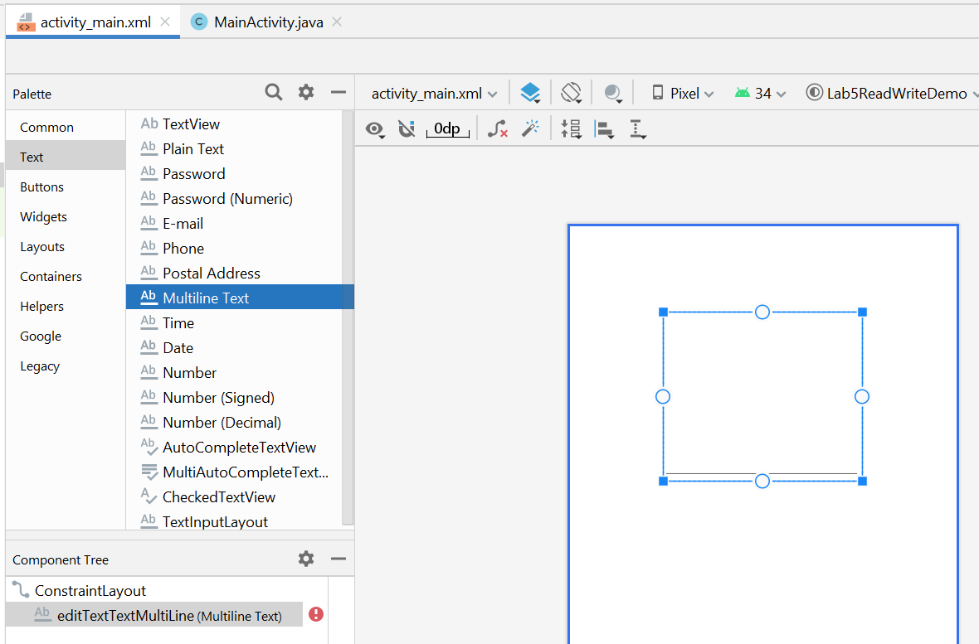

Run the app and input some text

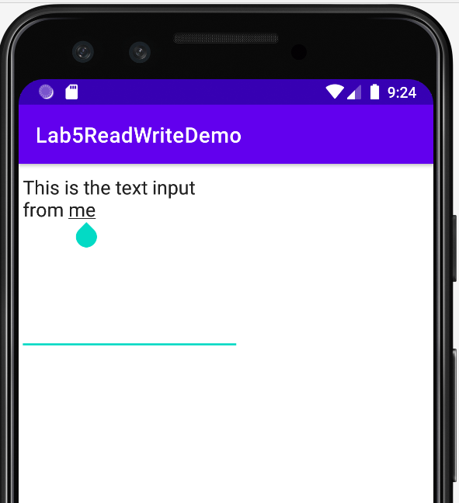

And then navigate away from the app (or close it)

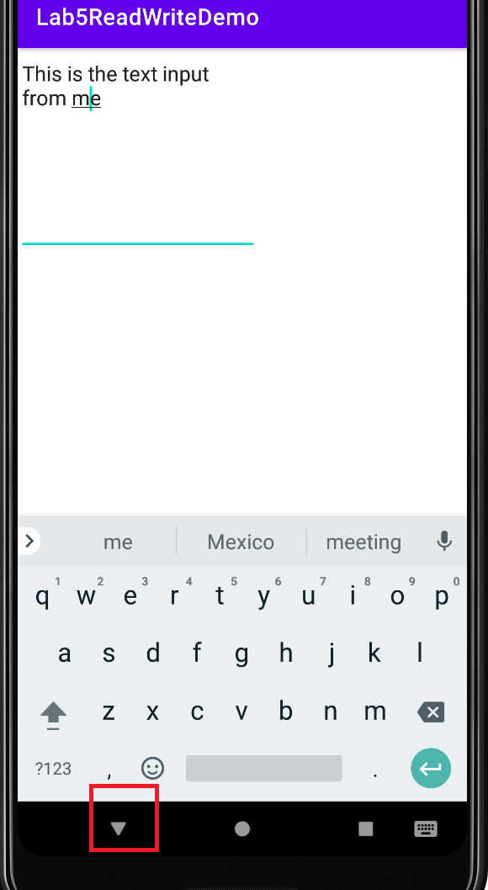

Now see the data is not kept anymore

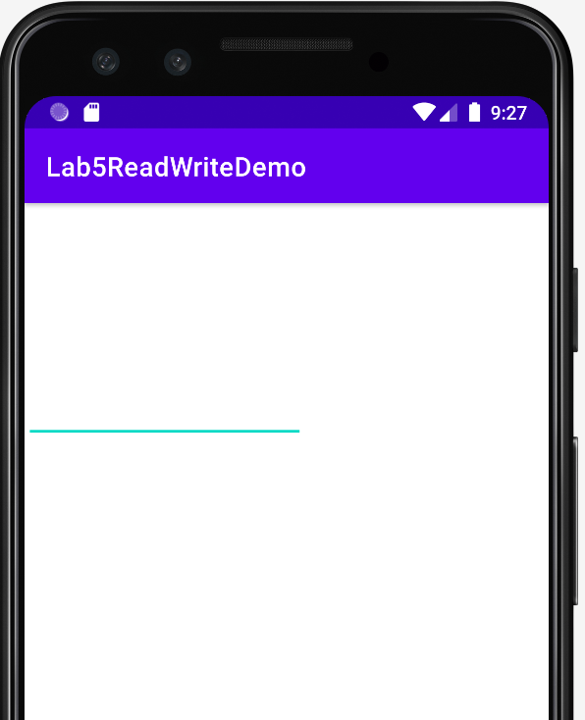

It is the reason that we want to save the input data and get it back when the users navigate away or close the app.

Save the data to a file when onPause() event is triggered

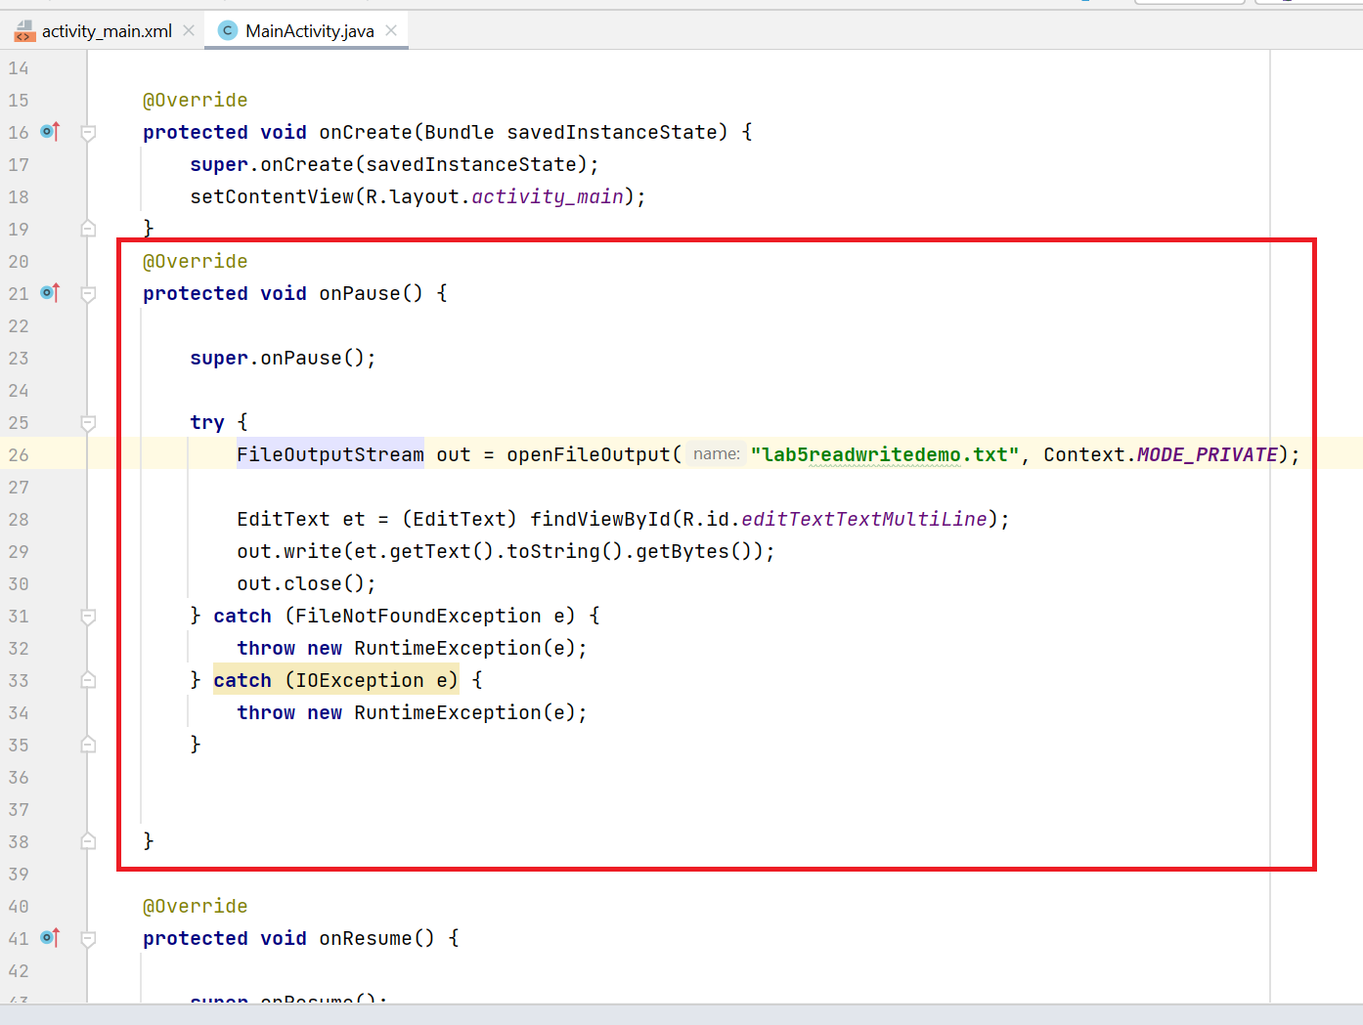

Restore the input data when onRestore() event is triggered

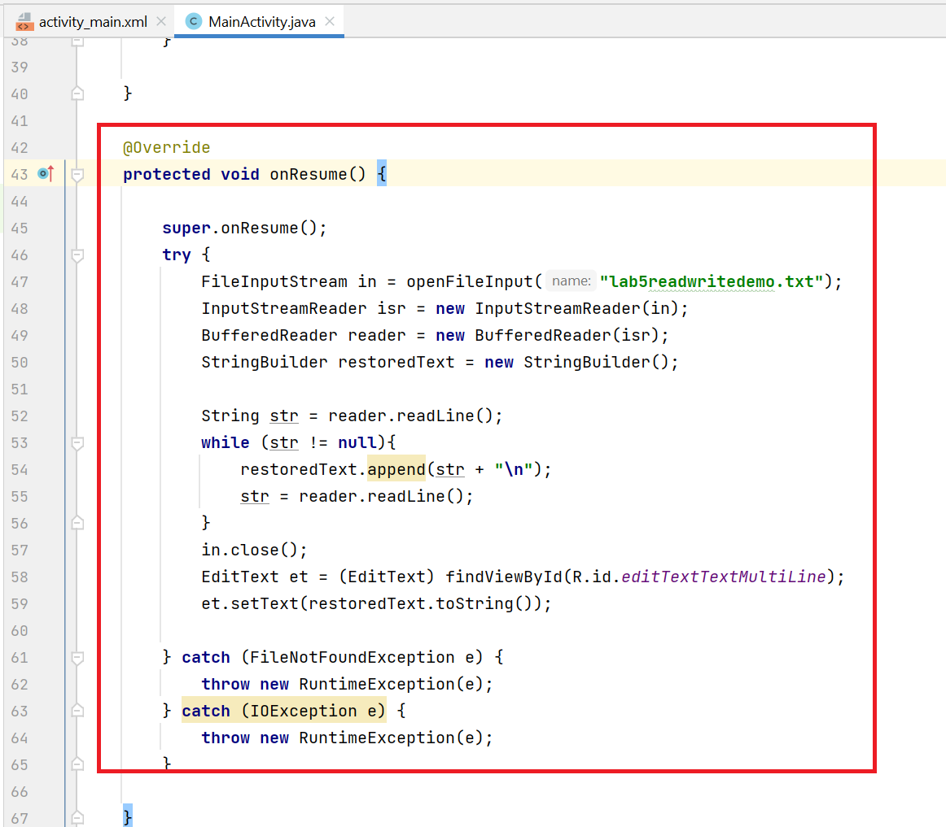

Run the app

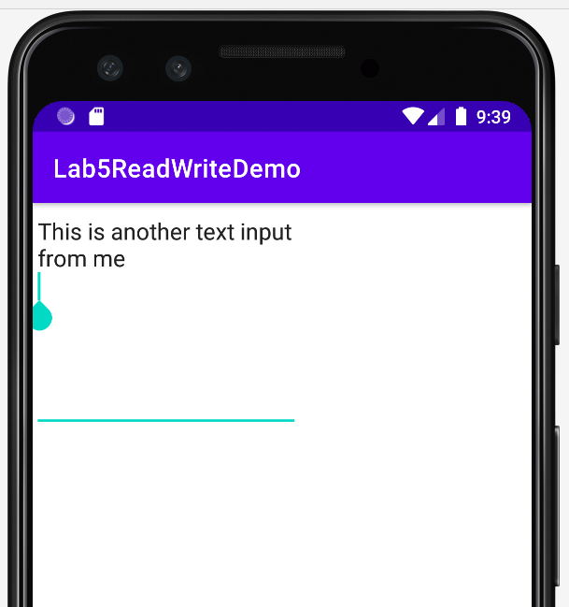

Navigate away or close the app

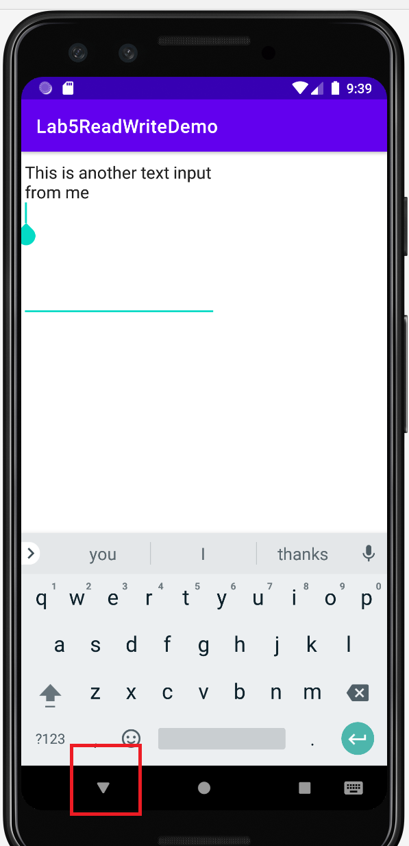

Open it back, see the text is restored. The original input is now kept

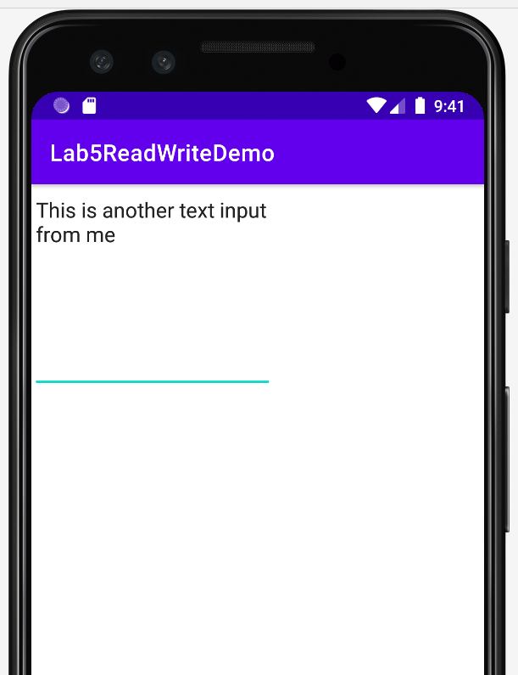

Check the file

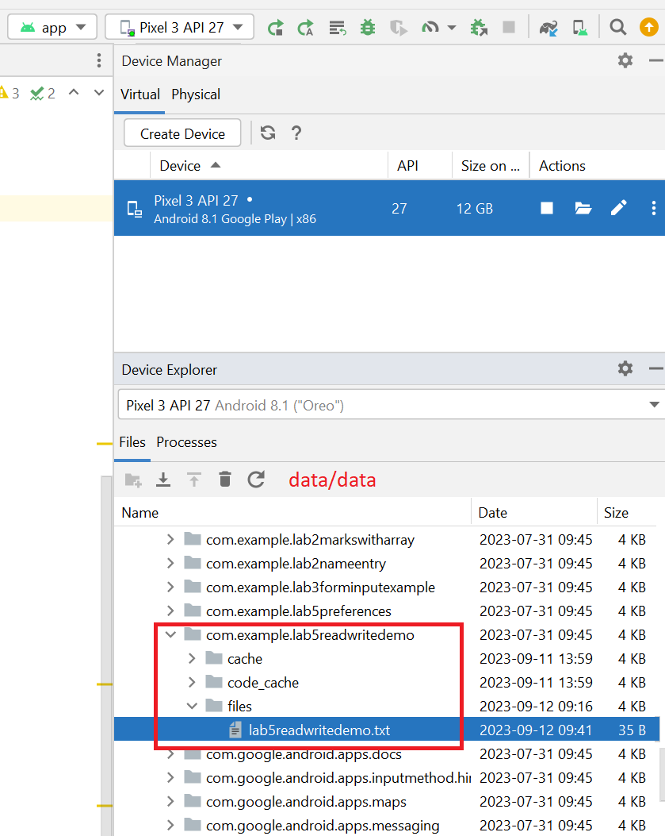

**END OF PART 2**

**PART 3**

Implement the Database example from the lecture slides.

*Guidelines:*

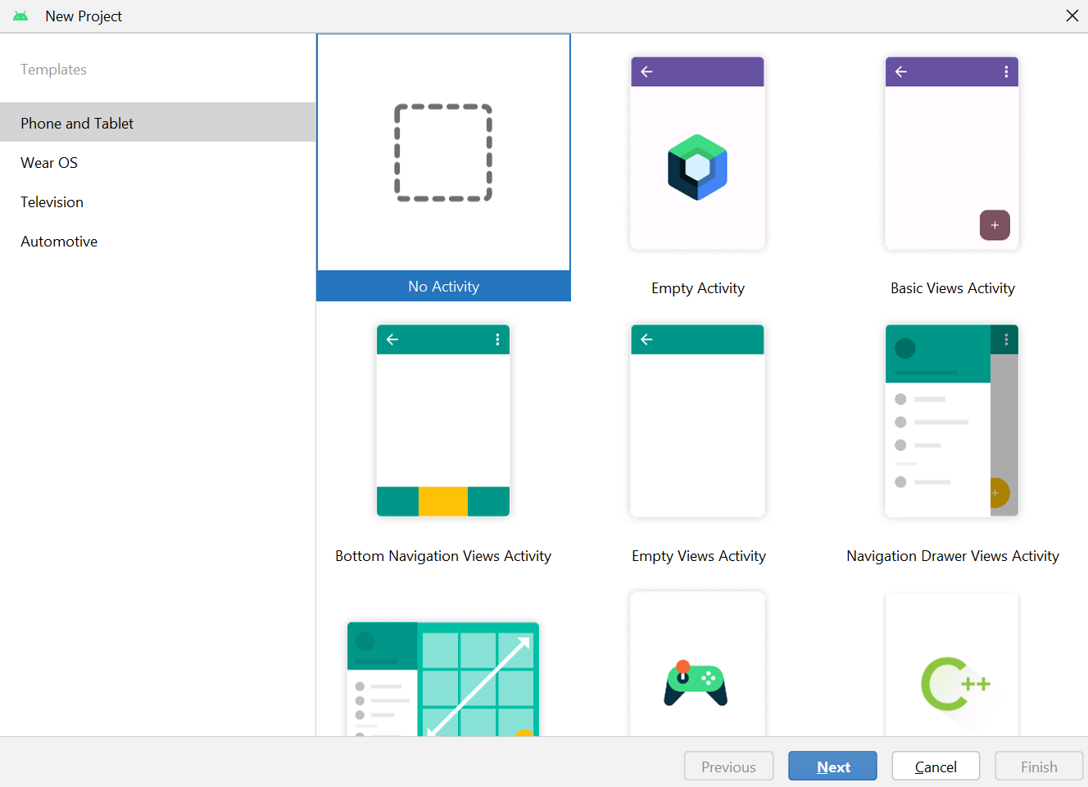

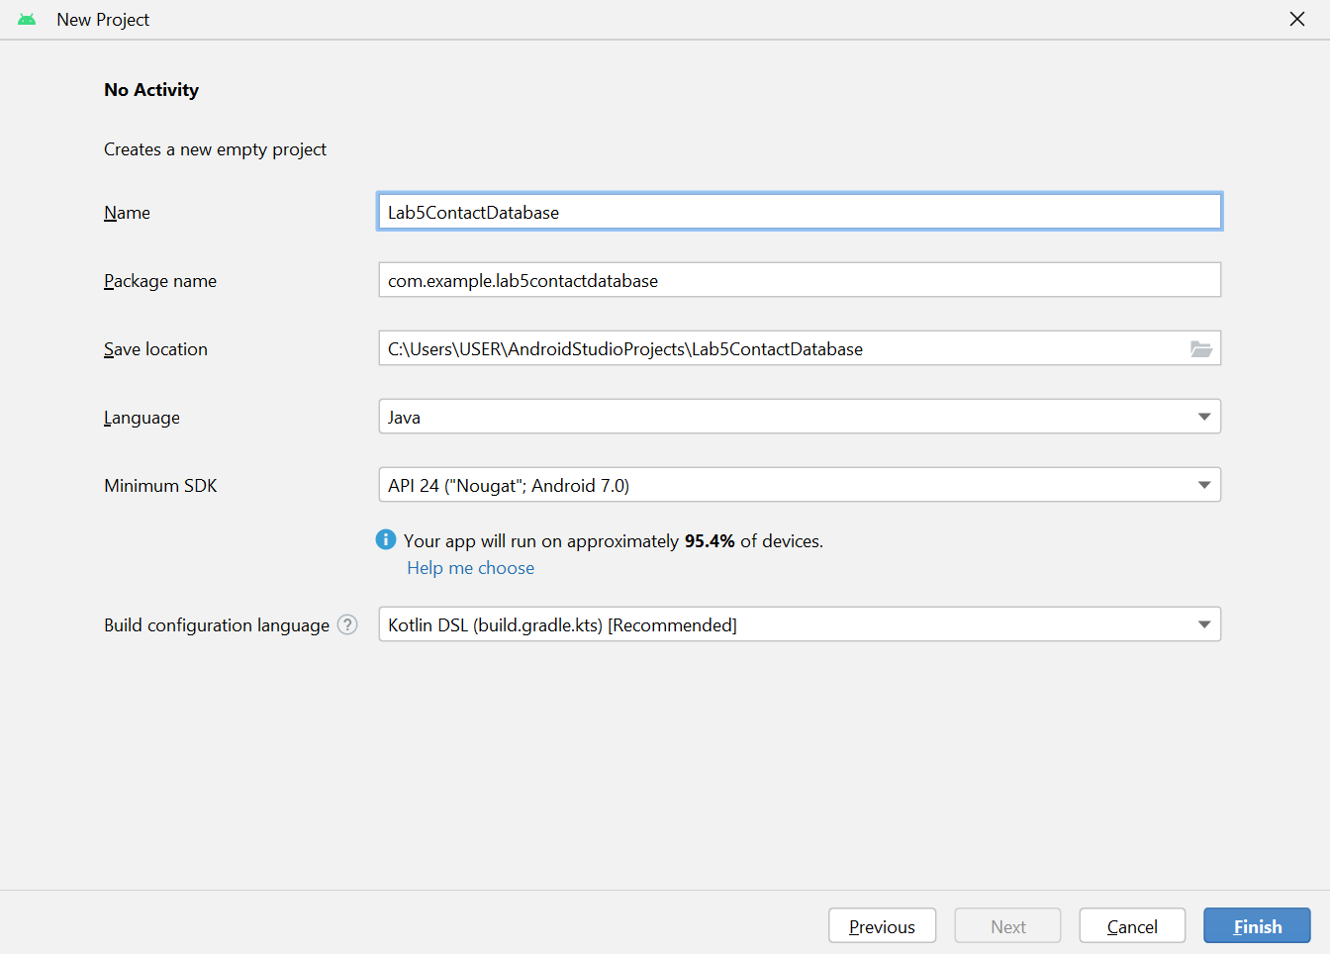

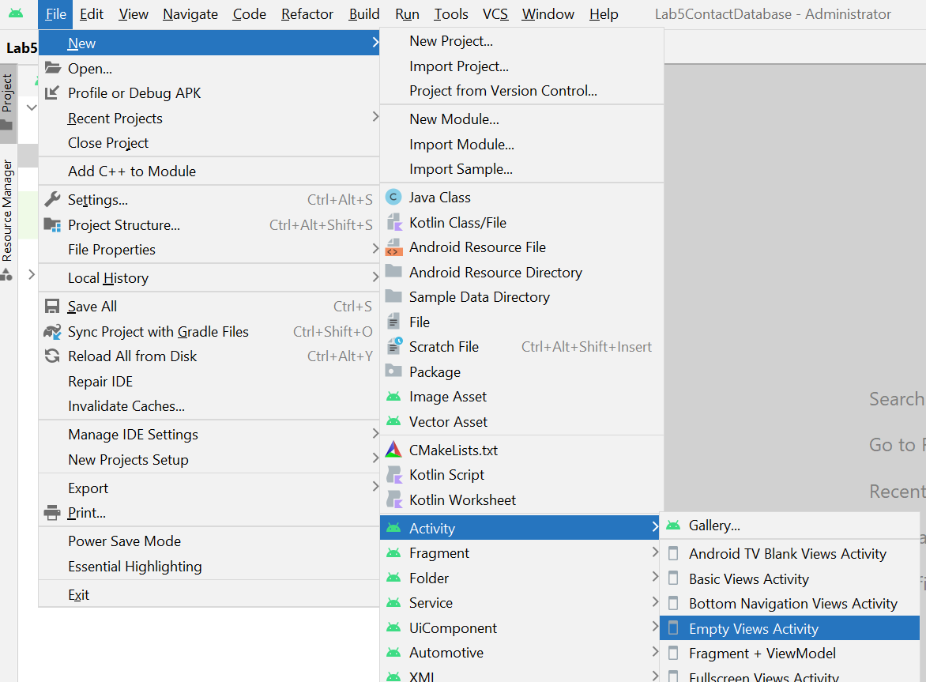

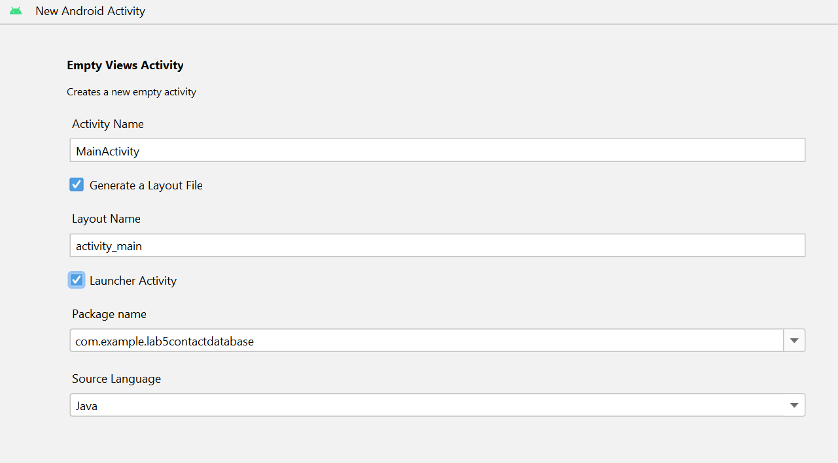

Create a layout

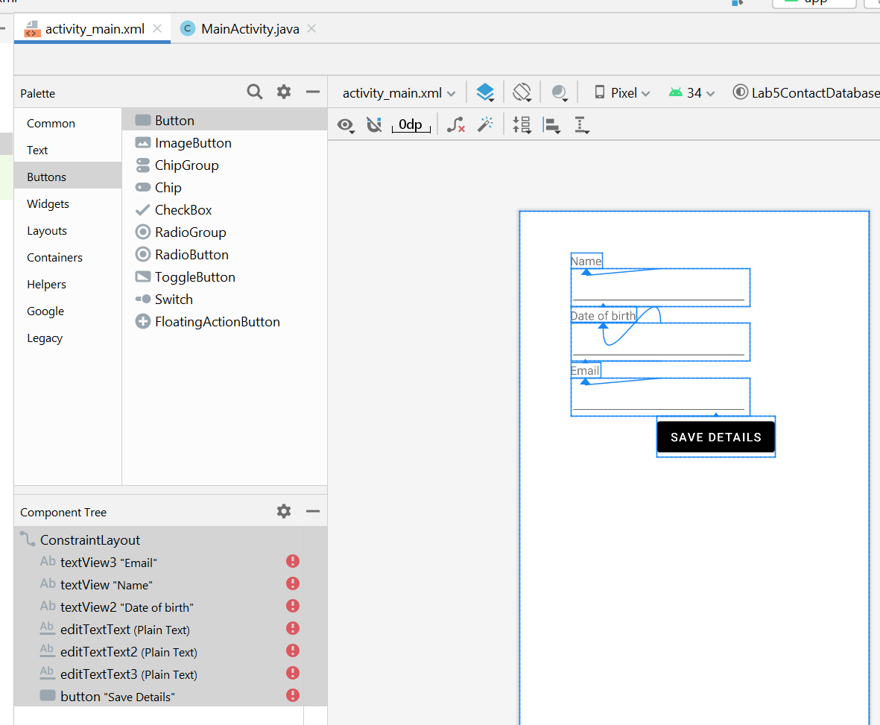

Run and see the layout

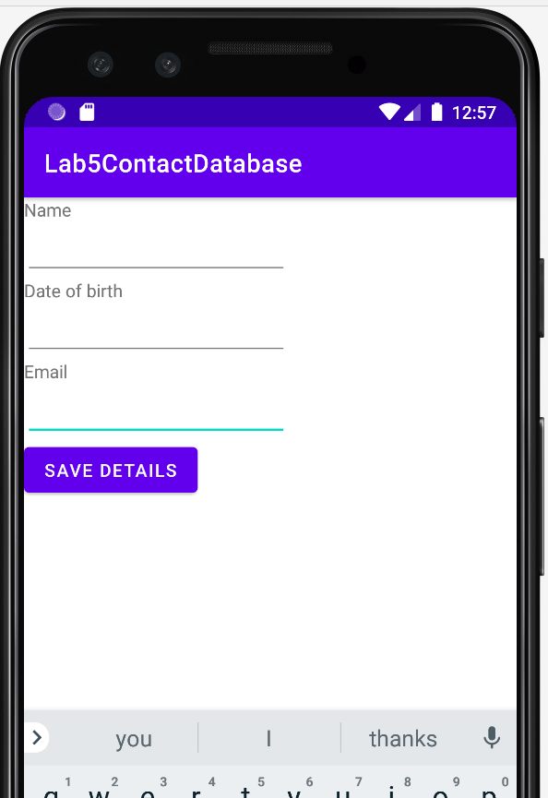

Create a new java class

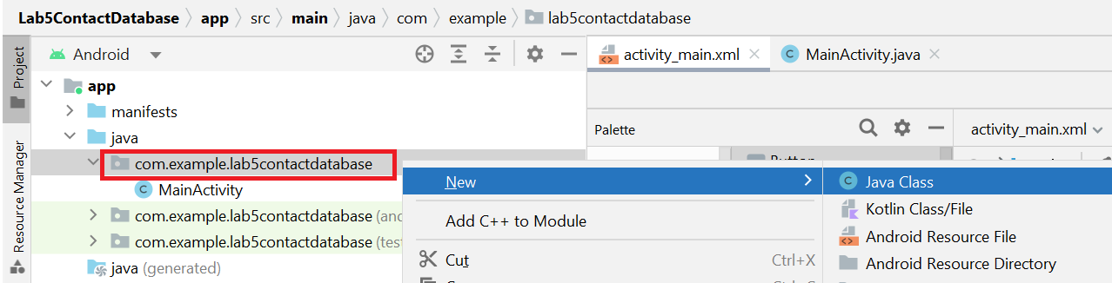

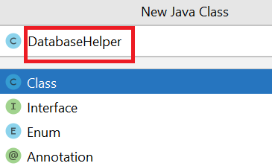

A helper class is a terminology. Developers usually create helper classes to implement some methods which “help” them to do some data manipulation. Therefore, these classes act as utility classes.

Now Furnish the DatabaseHelper class

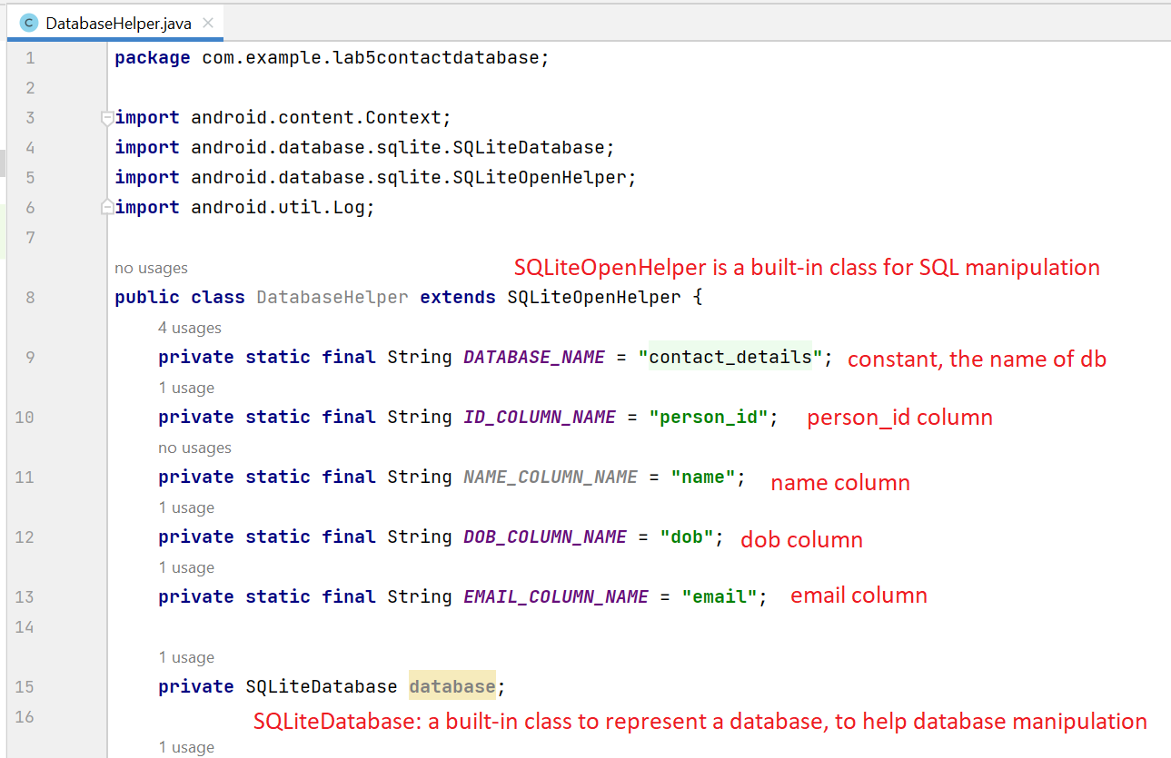

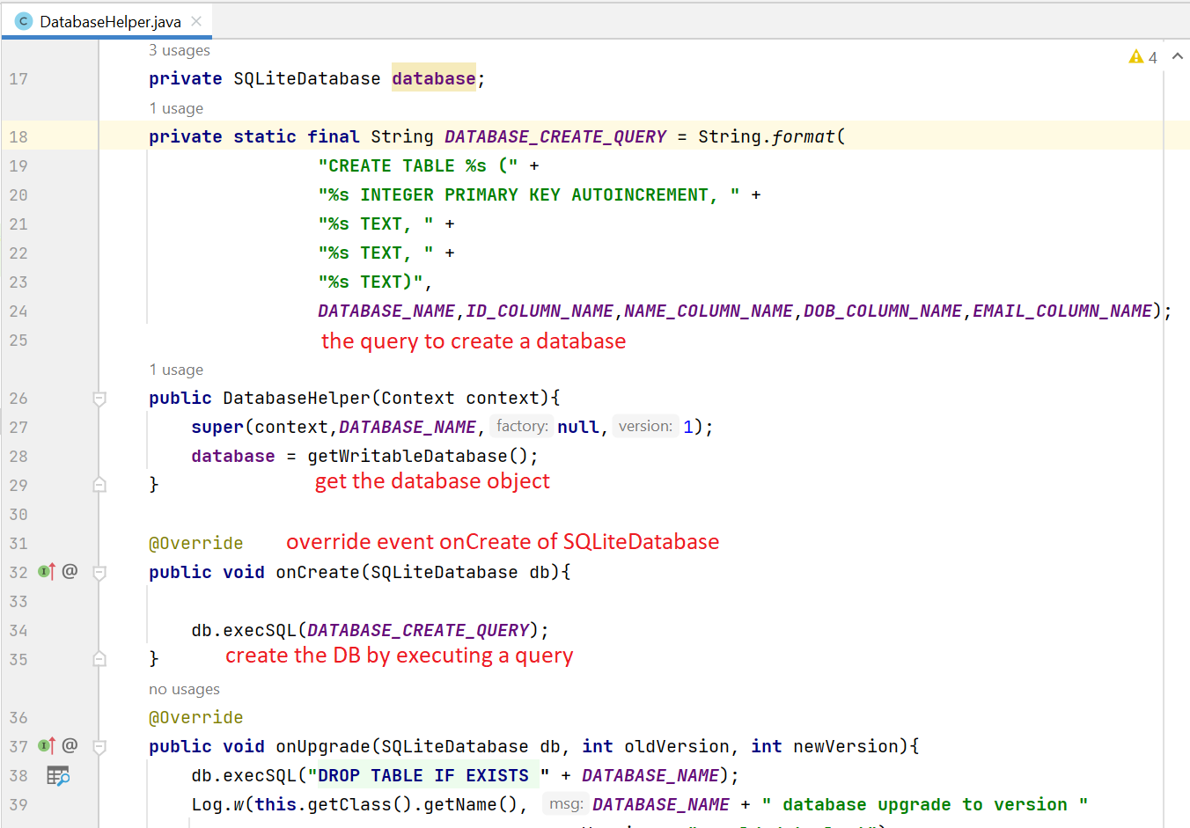

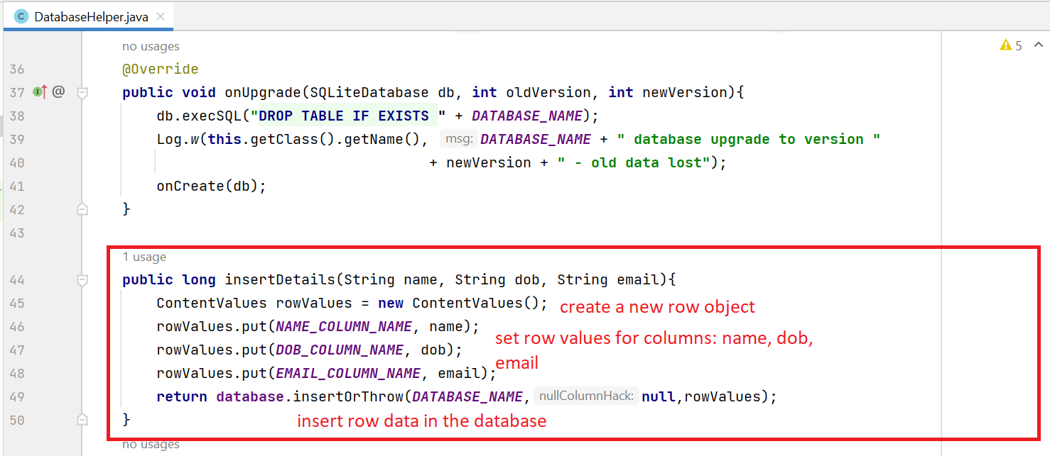

Explanations:

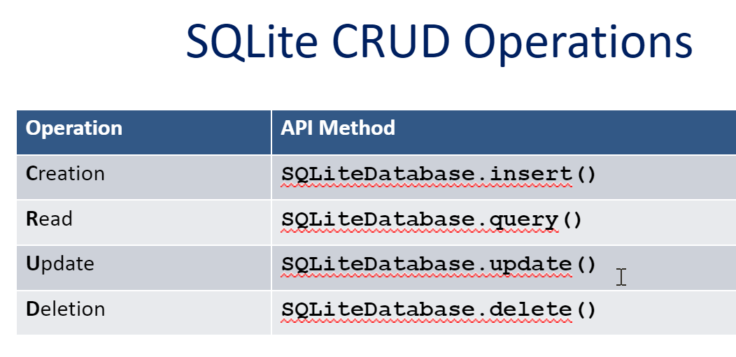

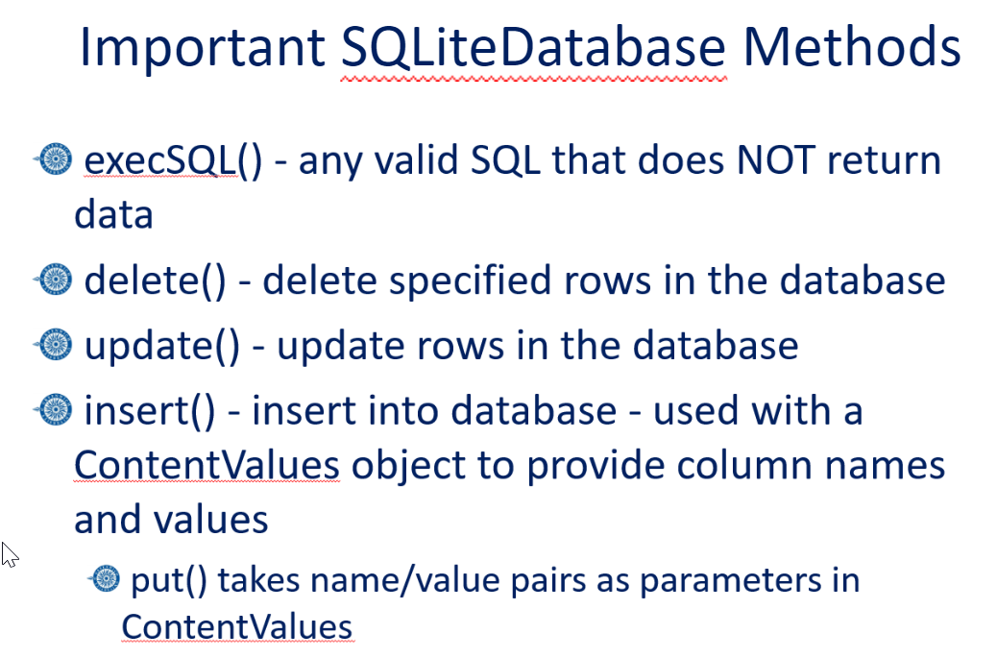

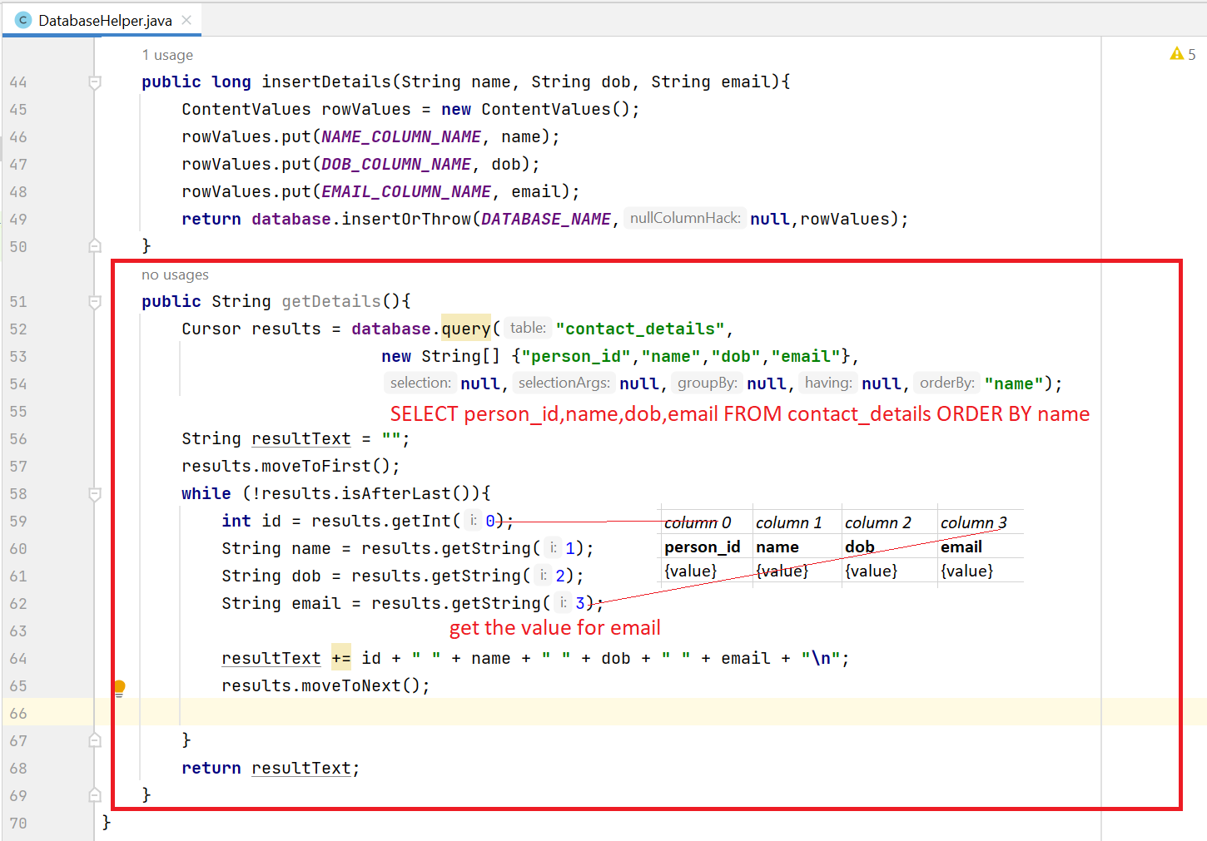

*Explanations:*

*-***Cursor** is a built-in class, representing a list of rows

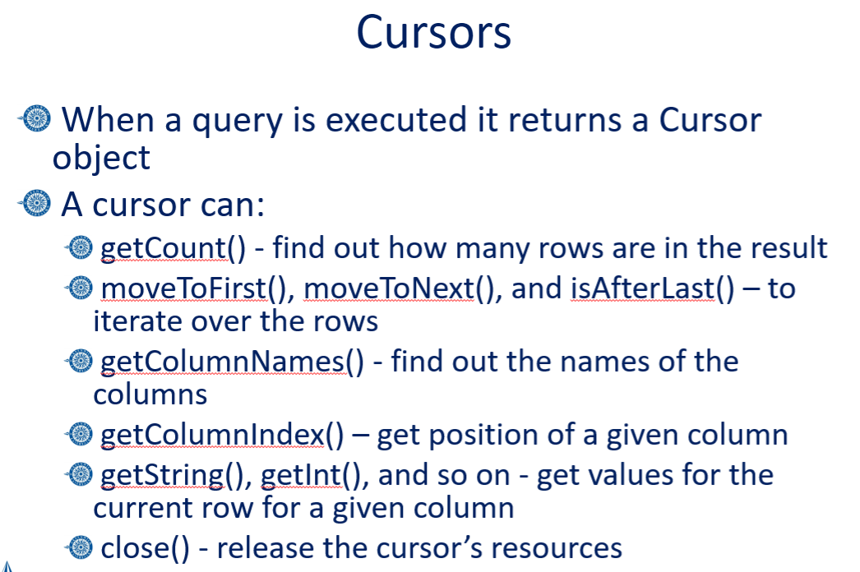

Update MainActivity.java

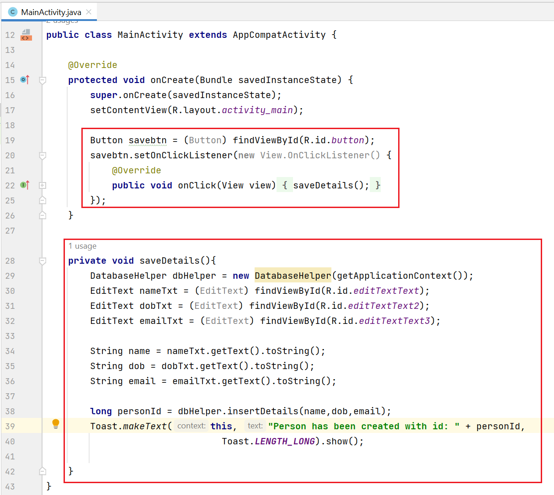

Run the app and input name, dob and email. Then click Save

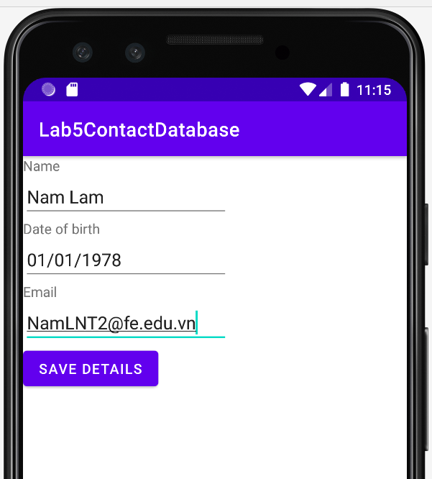

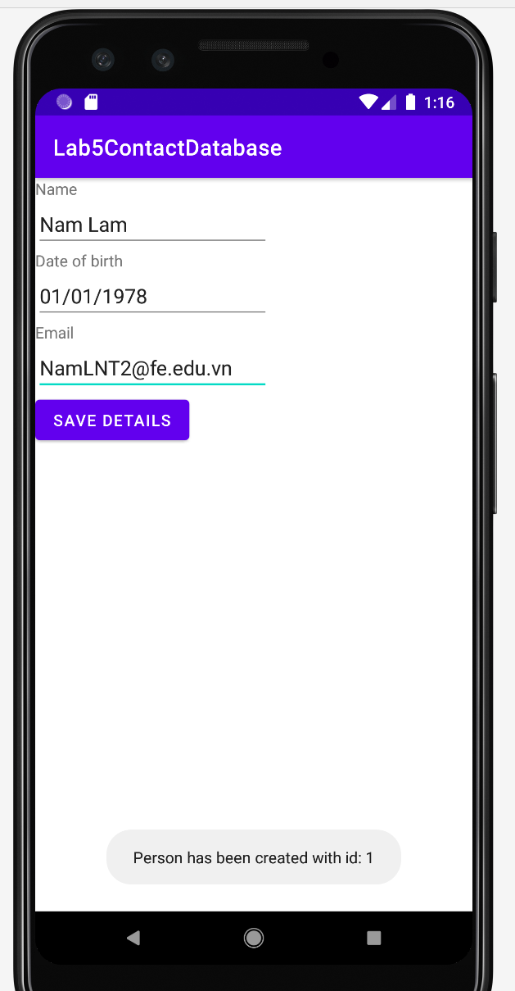

Now see the database file

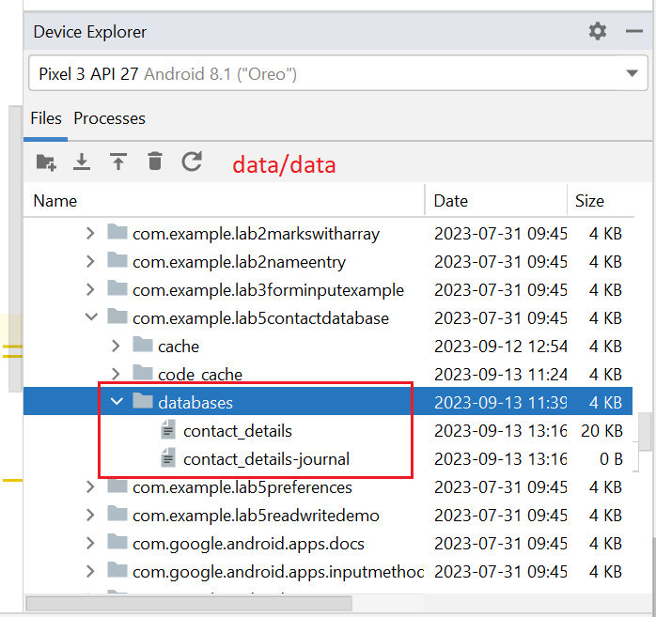

Use AppInspection to check data in the database

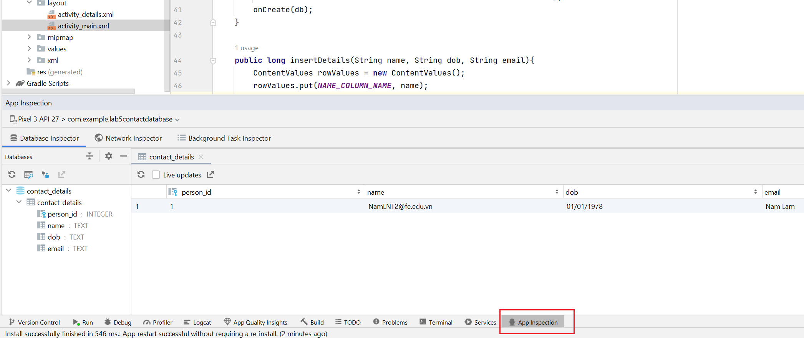

Create the 2nd activity: DetailsActivity, to show the list of all persons (as text)

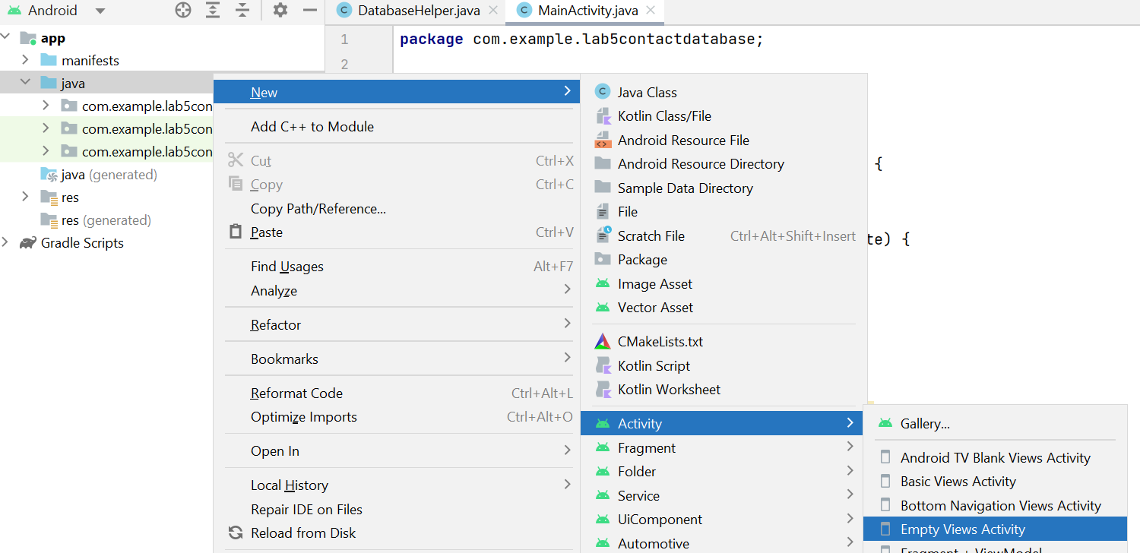

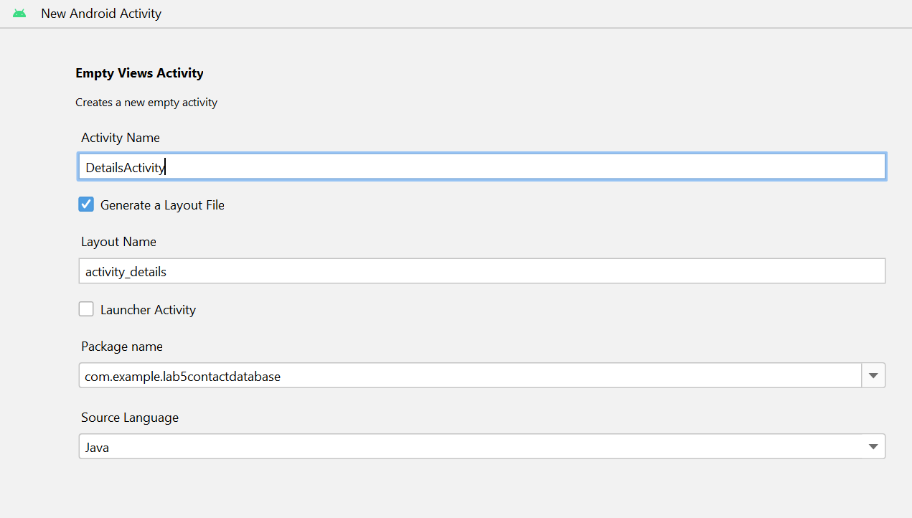

Add a textview to the layout

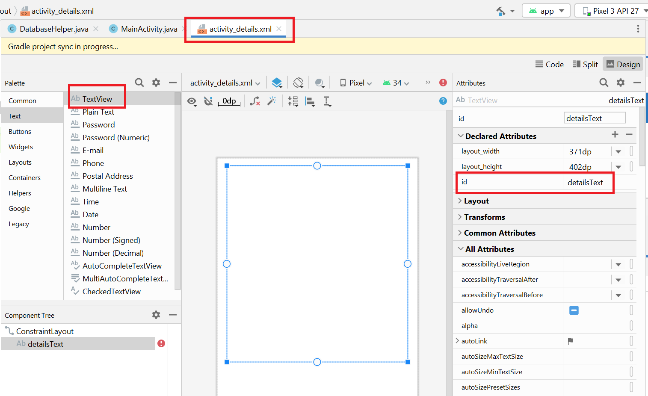

Start the activity when users click on Save

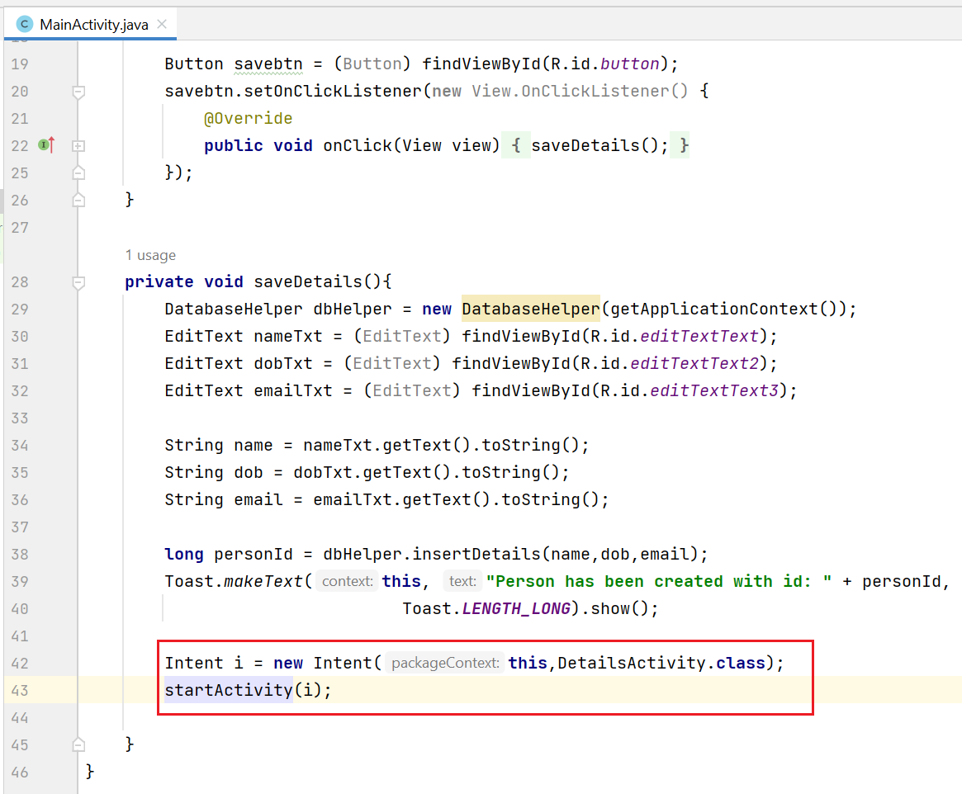

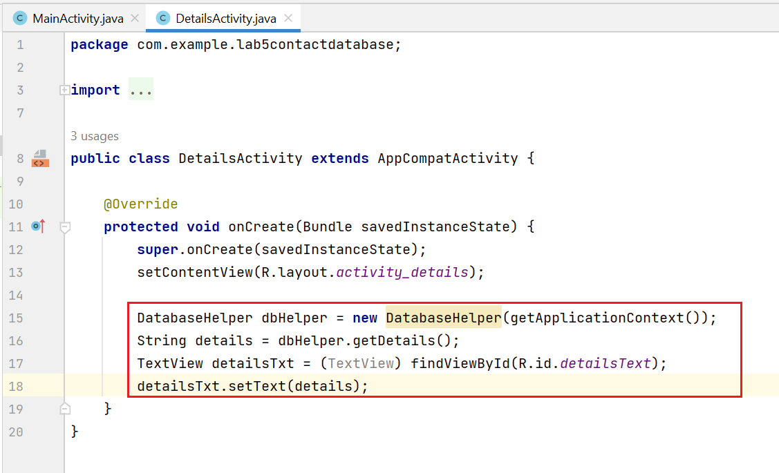

Run the app

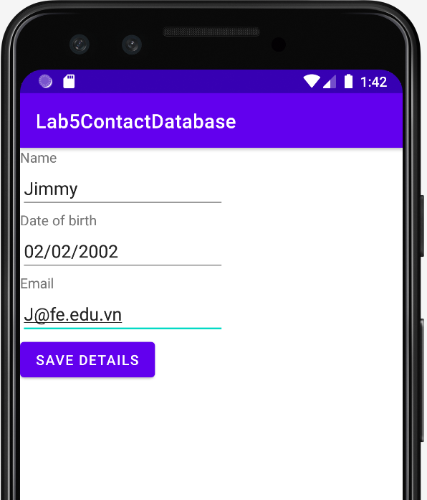

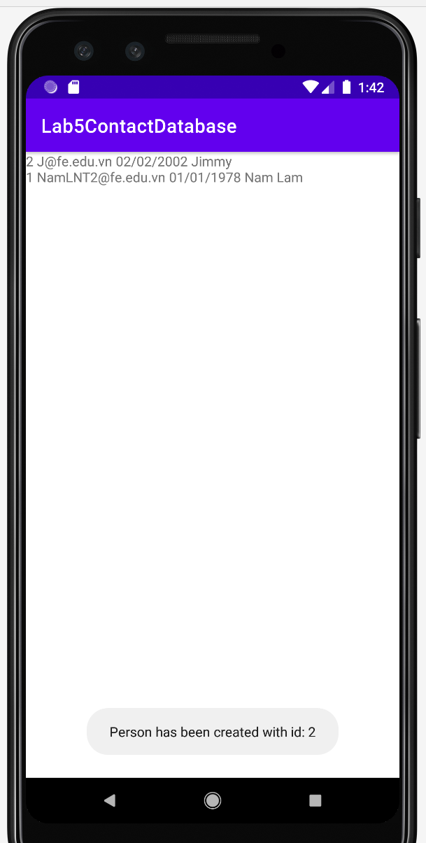

App Inspection

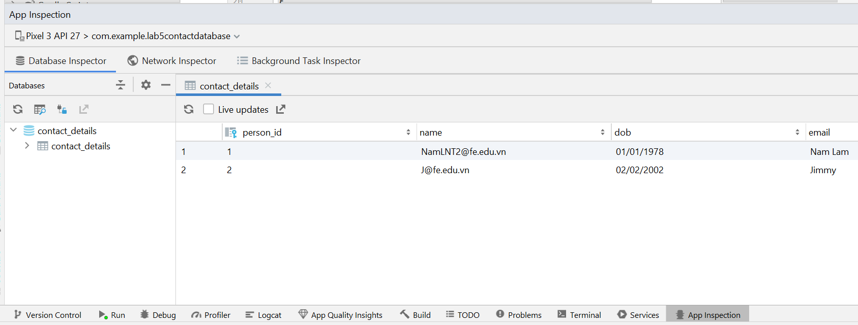

**END OF PART 3**

**PART 4**

Amend the ContactDatabase implementation to include a second table called *skills* and allow the user to input two skills per person which should be stored in the second table.

*Guidelines:*  Similar to PART 3

**END OF PART 4**

**PART 5**

Amend the ContactDatabase implementation to add a Person class and use instances of this class when you prepare data to write to database and when you are reading the content from the database (the getDetails() method in the DatabaseHelper class should return an array of Person objects).

*Guidelines: no guidelines*

**END OF PART 5**